SIMATS ENGINEERING
Department of Information Technology
CSA15 – CLOUD COMPUTING AND BIG DATA ANALYTICS
ASSIGNMENT 2 – CO2
Analyse, Evaluate and Validate a Virtualization Architecture for a Multi-Tenant University Private Cloud
CO2: Analyze virtualization architectures to identify performance and security issues in cloud computing environments.
Field | Details | Field | Details
Student Name | N.Rama Sai Kiran Reddy | Register Number | 192525044
Department / Section | AI&ML | Academic Year / Semester | 2026
Faculty Name | Dr Latha R | Nature of Assignment | Individual
Duration | 1 Week | Total Marks | 50
Submission Date | 4/11/2026 | Evaluation Date
MARK SHEET (Rubric-based evaluation)
Task | Title | Max | Awarded | Evidence / evaluation focus
1 | Characterise the Virtualization Architectures | 5
2 | Identify the Dominant Overhead Source | 2
3 | Build a Quantitative Performance Model | 6
4 | Analyse Performance Under Different Conditions | 4
5 | Security Threat and Vulnerability Analysis | 3
6 | Formulate Isolation–Performance Trade-off | 3
7 | Evaluate Mitigation Strategies | 4
8 | Implement and Test | 4
9 | Record Experimental Performance | 3
10 | Compare Theory with Experiment | 4
11 | Recommend and Defend Final Architecture | 4
12 | Day-4 Design Challenge | 8
 | TOTAL | 50
OVERALL REMARKS
Overall, the assignment reflects good analytical ability, technical understanding and problem-solving skills in cloud computing and virtualization. The proposed architecture balances performance, security, resource efficiency and future scalability. The work can be further strengthened through verified experimental results, consistent benchmark comparisons and practical validation of the recommended security controls.
Student Signature | Faculty Signature | Program Director
N.Rama Sai
MANDATORY SUBMISSION EVIDENCE CHECK
✓ = Present in documented answer; P = Partly present; X = Missing / not satisfied
Task | Evidence expected | Status | Evaluator note
1 | Three virtualization architectures, layered diagrams and trust boundaries
2 | Dominant overhead source identified and explained for each approach
3 | CPU, memory, I/O, network and density models with assumptions
4 | Best, typical and worst operating-condition analysis
5 | Threat model and architecture-based security comparison
6 | Isolation–performance optimization formulation
7 | Mitigation benefits, residual risks and quantified costs
8 | Reproducible setup and practical tests across selected platforms
9 | Actual comparative measurements, table and two graphs
10 | Theory–experiment comparison and quantitative error analysis
11 | Justified SIS/LMS architecture and growth recommendation
12 | Day-4 external tenants, 3× peaks, live migration and SIS isolation
IMPLEMENTATION EVIDENCE CHAIN
Evidence item | Status | Observation
Architecture diagrams
Performance model
Configuration / scripts
Virtualization experiments
CPU / disk / network / memory tests
Noisy-neighbour experiment
Security validation
Tables and graphs
Theory–experiment consistency
Day-4 design defence
Screenshots
SUBMISSION CHECKLIST (Not Separately Marked)
Requirement | Status
All 12 tasks answered | ☐ Yes ☐ Partly ☐ No
Three virtualization approaches compared | ☐ Yes ☐ Partly ☐ No
Layered diagrams and trust boundaries included | ☐ Yes ☐ Partly ☐ No
Quantitative virtualization models included | ☐ Yes ☐ Partly ☐ No
Threat analysis and mitigations included | ☐ Yes ☐ Partly ☐ No

CLOUD COMPUTING AND BIG DATA
ASSIGNMENT 2
CO2: Analyze virtualization architectures to identify performance and security issues in cloud computing environments.
Assignment Title: Analyse, Evaluate and Validate a Virtualization Architecture for a Multi-Tenant University Private Cloud (Total Marks: 50)
Duration: 1 week
Scenario: EduCloud Virtualization Platform
A university runs a private cloud, EduCloud, in its data centre. EduCloud currently consists of:
- 16 physical hosts, each with 64 CPU cores, 512 GB RAM, NVMe SSD storage and 2 × 25 Gbps NICs
- About 400 virtual machines (VMs) running the Student Information System (SIS), the Learning Management System (LMS), the examination portal, and departmental research workloads
- A shared storage backend and a software-defined virtual network
During semester registration week, users report slow response times and failed logins. A recent internal security audit also found that VMs from different departments share the same physical hosts, that some VMs run outdated guest kernels, and that VM images are copied freely between teams.
You are the cloud architect. You must investigate, model, measure and compare virtualization architectures for EduCloud, identify their performance bottlenecks and security weaknesses, and recommend a design that remains practical as the platform grows.
Design Challenge:
The university now plans to host external research collaborators' big-data workloads (Spark/Hadoop clusters) on the same infrastructure as the SIS. Reevaluate your design under these new multi-tenant conditions.
TASK 1: Characterise the Virtualization Architectures (5 Marks)
Select at least three meaningfully different virtualization approaches from the following, or justify others:
- Type-1 (bare-metal) hypervisor with full virtualization
- Type-2 (hosted) hypervisor
- Hardware-assisted virtualization vs. paravirtualization
- OS-level virtualization (containers)
- Lightweight/micro-VM or sandboxed container runtimes
Two configurations of the same hypervisor will not count as different approaches. Your selection must include at least one VM-based and at least one container-based approach.
For each approach, provide:
- A layered architecture diagram showing the hardware, host OS or hypervisor, guest OS, runtime and application
- The trust boundaries and the component that enforces isolation
- How CPU, memory, storage and network are virtualized
- A brief justification for why this approach is relevant to EduCloud
Evidence expected: Three architecturally distinct approaches with labelled diagrams, resource-virtualization mechanisms, trust boundaries, and justification of selection.
TASK 2: Identify the Dominant Overhead Source (2 Marks)
For each approach, identify the primary source of performance overhead that predominantly limits its performance (for example VM exits/traps, nested or extended page-table walks, virtual I/O emulation, virtual switch processing, or system-call interception).
Discuss:
- What the overhead source is
- Where in the architecture it occurs
- Why it is appropriate as the focus of performance analysis
- How its frequency or cost changes as the number of co-located VMs/containers or the I/O rate increases
Do not simply name a mechanism. Relate it to the behaviour of the architecture.
Evidence expected: A justified dominant-overhead identification for each approach, linked to its resource-virtualization path.
TASK 3: Build a Quantitative Performance Model (6 Marks)
Using the following host parameters, develop an analytical performance model for each approach.
Parameter | Value
Physical cores per host | 64
vCPU:pCPU overcommit ratio | 1:1, 2:1, 4:1, 8:1
RAM per host | 512 GB
Average VM memory demand | 8 GB
Cost of one VM exit (assume) | 1.5 µs
Native system-call cost (assume) | 0.2 µs
Network line rate | 25 Gbps

State and justify any additional assumptions. Derive expressions for:
- CPU: effective per-VM CPU capacity as a function of overcommit ratio and virtualization overhead (including steal time)
- Memory: the maximum number of VMs per host before ballooning, swapping or page-sharing becomes necessary
- I/O and network: effective throughput as a function of the number of VMs sharing the physical device
- Density: the number of VMs/containers a host can support while meeting a stated service-level target (for example, ≤ 10% performance degradation)
Show the mathematical reasoning. Merely quoting overhead percentages from the literature will not receive full credit.
Evidence expected: A clear mathematical derivation for each approach, with stated assumptions, parameter values and worked numerical examples.
TASK 4: Analyse Performance Under Different Operating Conditions (4 Marks)
Analyse how each approach behaves under three conditions:
- Best case: what workload and placement conditions minimise overhead?
- Typical case: for example, registration-week mixed web and database load
- Worst case: for example, noisy-neighbour interference, memory overcommit with swapping, live migration during peak load, or I/O storms
For each, explain what happens inside the virtualization layer, why the overhead changes, and how latency and throughput are affected. A table of numbers alone will not be accepted.
Evidence expected: A justified condition-based analysis supported by your Task 3 model.
TASK 5: Security Threat and Vulnerability Analysis (3 Marks)
Construct a threat model for each approach. Discuss:
- The attack surface (hypervisor, device emulation, shared kernel, management plane, VM images and snapshots, virtual network)
- At least four distinct threat categories, such as VM escape, cross-VM side-channel attacks, hypervisor or container-runtime vulnerabilities, VM sprawl and unpatched guests, image tampering, insecure live migration, and virtual-network sniffing or spoofing
- For each threat, which approach is more or less exposed and why, referring to its architecture and trust boundaries
- The likely impact on the confidentiality, integrity and availability of student records
Evidence expected: A structured threat model mapped to architectural features, with a justified comparison across approaches.
TASK 6: Formulate the Isolation–Performance Trade-off (3 Marks)
Formalise the trade-off between isolation strength and performance/density for EduCloud.
Clearly identify:
- The decision variables (for example, approach chosen, VMs per host, dedicated vs. shared hosts, SMT on/off)
- The objective(s), such as maximising density or minimising cost
- The constraints (for example, performance degradation limit, isolation requirement for SIS, available hosts)
- How these components combine into a cost or decision function
The formulation must follow from your own analysis in Tasks 3 and 5, not from a generic template.
Evidence expected: A clearly defined trade-off model with identified variables, objective and constraints.
TASK 7: Evaluate Mitigation Strategies (4 Marks)
Propose at least three mitigations for the vulnerabilities identified in Task 5. Examples include disabling SMT, kernel page-table isolation, dedicated hosts for sensitive tenants, secure or sandboxed container runtimes, hardware memory encryption, image signing, and micro-segmentation.
For each mitigation, discuss:
- Why it is applicable to the threat
- What residual risk remains
- The performance or density cost, estimated using your Task 3 model
- Whether the trade-off is acceptable for the SIS
Evidence expected: Mitigations evaluated analytically, with their security benefit and quantified performance cost.
TASK 8: Implement and Test (4 Marks)
Build a test environment and experimentally test all selected approaches.
- Platforms: use any open-source stack, for example KVM/QEMU, Xen or VirtualBox, Docker/Podman, and Kata Containers or gVisor. Nested virtualization on a laptop is acceptable if documented.
- Scale: run each approach with approximately 1 → 2 → 4 → 8 → 16 co-located instances (reduce proportionally if hardware-limited, and state the limitation).
- Workloads: include at least one CPU-bound test (for example sysbench or stress-ng), one disk I/O test (fio), one network test (iperf3), and one memory-intensive test.
- Interference test: run at least one noisy-neighbour experiment.
- Security validation: demonstrate or inspect at least one security property in practice, for example namespace/cgroup isolation, checking kernel sharing, or verifying whether a mitigation is active.
Ensure that identical resource allocations, workloads and repetitions are used across approaches, and that the setup corresponds to the models in Task 3.
Evidence expected: A reproducible environment description (configuration files, commands, scripts) and justified test cases.
TASK 9: Record Experimental Performance (3 Marks)
Collect and present data such as:
- Throughput, latency (mean and 95th percentile), CPU steal time, context switches and VM exits where observable
- Instance start-up time and memory footprint per instance
- Performance degradation versus a bare-metal baseline
- Results with and without at least one security mitigation
Present at least one table and two graphs (for example, throughput versus number of instances, and latency under interference). Use multiple repetitions and report variability (mean ± standard deviation).
Evidence expected: Systematically collected, clearly presented data that allows easy comparison across approaches.
TASK 10: Compare Theory with Experiment (4 Marks)
Compare your Task 3 and Task 4 predictions with Task 9 measurements.
Discuss:
- Whether the observed degradation trends agree with your model
- Which approach scales better as co-located instances increase
- Quantitative differences between predicted and measured values, and plausible causes (for example caching effects, hypervisor scheduler behaviour, nested virtualization, laptop hardware, or unmodelled I/O paths)
- Whether any measured result changes your security conclusions from Task 5
Interpret the results; do not simply reproduce tables.
Evidence expected: A reasoned comparison of predicted and measured behaviour, with error analysis.
TASK 11: Recommend and Defend the Final Architecture (4 Marks)
Recommend the virtualization architecture (or hybrid) for EduCloud's SIS and LMS workloads.
Discuss:
- Which approach you recommend and why it is more appropriate than the alternatives
- Its modelled and experimentally observed performance
- Its security posture and residual risks
- Operational costs such as patching, image management, migration and monitoring
- Limitations and trade-offs
- Whether it remains practical as EduCloud grows from 400 to several thousand instances
Your recommendation must rest on your own analysis and experiments. Choosing "the most secure" or "the fastest" option alone is not sufficient.
Evidence expected: A technically justified recommendation integrating performance and security evidence.
DAY-4 DESIGN CHALLENGE
TASK 12: Re-evaluate and Adapt the Design (8 Marks)
Changed Requirement
The university will now host external research collaborators' Spark/Hadoop workloads on EduCloud alongside the SIS. The new conditions are:
- Big-data jobs are I/O- and network-intensive and run for hours
- Registration-week peak load is about 3× normal
- Hosts are sometimes patched using live migration of running VMs
- A data-protection regulation now requires demonstrable isolation of student records from external tenants
You may RETAIN → MODIFY → or REDESIGN your original solution.
A. Impact Analysis (2 Marks)
Discuss what has changed, which original assumptions (trusted tenants, workload mix, I/O profile) no longer hold, and how mixing batch big-data workloads with latency-sensitive SIS workloads changes both the performance and the threat model.
B. Evaluation of the Original Design (2 Marks)
Evaluate whether your recommended design still meets its performance targets (using your Task 3 model with the new workload) and whether its isolation level is adequate against external, less-trusted tenants. Consider whether another architecture could do better overall.
C. Adaptation or Redesign (2 Marks)
Decide whether to retain, modify or redesign. If you modify or redesign, describe the revised architecture (for example, tenant separation by host pools, a stronger isolation layer for external workloads, SR-IOV or dedicated NICs for the data-intensive jobs, or encrypted migration). Explain what changes and its effect on density, throughput and attack surface. If you retain, justify why no change is required.
D. Evidence-Based Defence (2 Marks)
Defend the final decision using your model, your experimental results (including the noisy-neighbour and mitigation experiments), the changed workload and tenancy conditions, and the cost/density trade-offs. The decision must follow logically from the analysis.
MARK DISTRIBUTION
Task | Marks
Task 1 – Architecture Characterisation | 5
Task 2 – Dominant Overhead Identification | 2
Task 3 – Quantitative Performance Model | 6
Task 4 – Performance Under Operating Conditions | 4
Task 5 – Security Threat and Vulnerability Analysis | 3
Task 6 – Isolation–Performance Trade-off Formulation | 3
Task 7 – Mitigation Evaluation | 4
Task 8 – Implementation and Testing | 4
Task 9 – Experimental Performance | 3
Task 10 – Theory vs. Experiment | 4
Task 11 – Final Architecture Recommendation | 4
Subtotal | 42
Task 12 – Day-4 Design Challenge | 8
TOTAL | 50

Task 1: Characterise the Virtualization Architectures
Three architecturally different approaches are selected: (A) KVM/QEMU hardware-assisted full virtualization, a VM-based approach; (B) Docker containers, an OS-level approach; and (C) Kata Containers, a micro-VM sandboxed runtime that combines a container workflow with VM-grade isolation. They differ in where the isolation boundary sits: the hypervisor and CPU hardware (A), the shared kernel (B), or a per-pod hypervisor boundary with a minimal guest kernel (C).

A. KVM/QEMU full virtualization
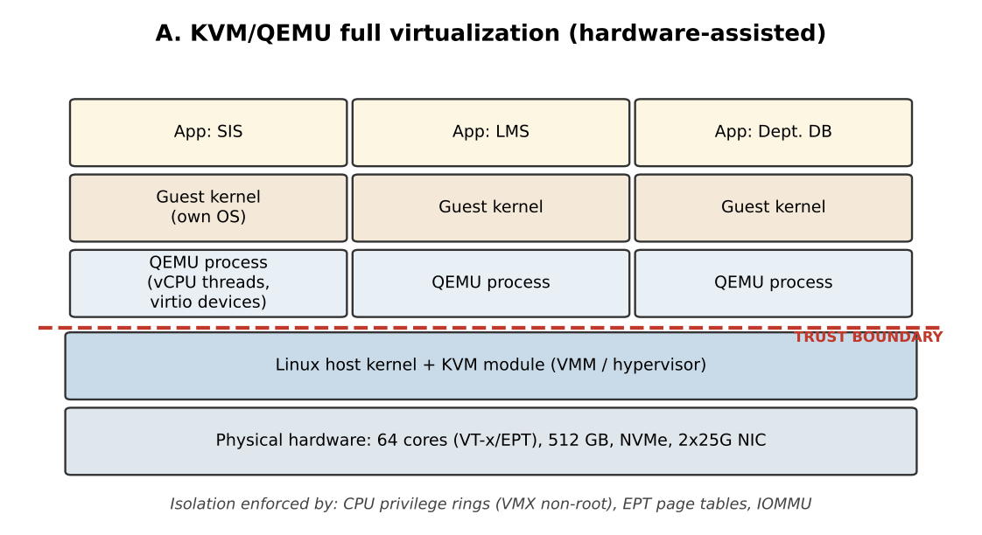
Figure 1.1: Layered architecture of KVM/QEMU with trust boundary
- Trust boundary and enforcement: between each guest and the host. Enforced by CPU virtualization extensions (VMX non-root mode), extended page tables (EPT) for memory and the IOMMU for device access. The QEMU process and host kernel are inside the trusted computing base.
- CPU: each vCPU is a host thread scheduled by the Linux scheduler; privileged instructions cause a VM exit handled by KVM. Memory: two-dimensional address translation (guest page table + EPT); ballooning and KSM page-sharing are optional. Storage: virtio-blk/virtio-scsi over image files or NVMe volumes. Network: virtio-net with vhost, attached to a Linux bridge or Open vSwitch.
- Relevance to EduCloud: strong isolation for SIS and examination data and support for live migration during host patching; mature management tooling.

B. Docker containers
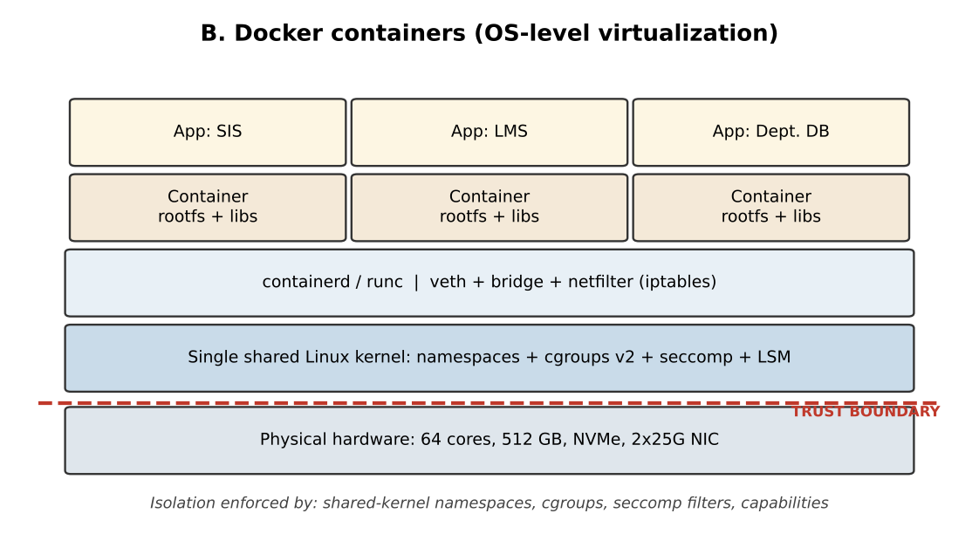
Figure 1.2: Layered architecture of Docker containers with trust boundary
- Trust boundary and enforcement: between containers and the host kernel. Enforced in software by namespaces, cgroups v2, seccomp, capabilities and AppArmor/SELinux. All containers share one kernel, so the kernel is the single point of enforcement.
- CPU: processes scheduled natively and capped by cgroup CPU shares/quotas. Memory: native pages limited by memory cgroup. Storage: overlayfs layers on the host filesystem. Network: veth pair to a bridge with iptables/nftables NAT or routing.
- Relevance to EduCloud: highest density and fastest start-up, suitable for stateless LMS web tiers, departmental tools and CI jobs where tenants are mutually trusted.

C. Kata Containers (micro-VM)
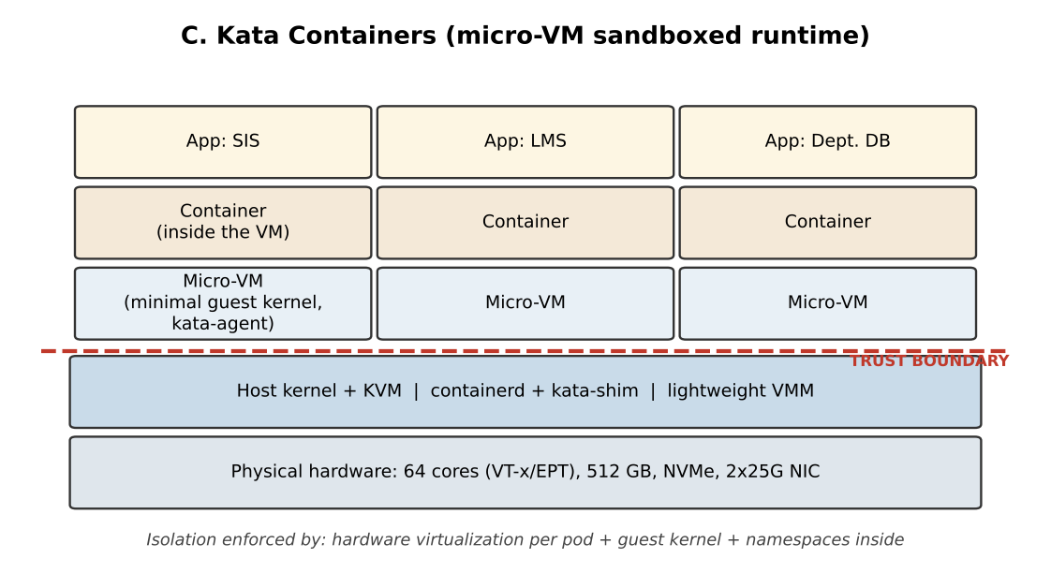
Figure 1.3: Layered architecture of Kata Containers with trust boundary
- Trust boundary and enforcement: between the micro-VM and the host, using the same hardware mechanisms as KVM, plus a second boundary (namespaces) inside the guest. A compromised container reaches only its own guest kernel.
- CPU/Memory: hardware-assisted like KVM but with a minimal guest kernel and agent, so footprint is small. Storage: virtio-fs or block devices to share image layers. Network: tc-mirror/veth to a tap device and virtio-net.
- Relevance to EduCloud: a container workflow with VM-level isolation, appropriate for untrusted external workloads such as the Day-4 Spark jobs.

1.4 Side-by-side comparison of the resource-virtualization mechanisms
Resource | A. KVM/QEMU | B. Docker | C. Kata
CPU | vCPU = host thread; hardware-assisted; privileged events cause VM exits | Ordinary processes; CFS bandwidth limits and cpusets | vCPU threads of a micro-VM; same hardware assist as A, fewer devices
Memory | Guest physical → host physical via EPT; ballooning, KSM, hugepages | Host virtual memory with memory-cgroup limit; shared page cache | Guest memory backed by host pages; hot-plug and DAX options reduce footprint
Storage | virtio-blk/SCSI on qcow2/raw/LVM; guest has own filesystem | overlayfs on host filesystem; bind mounts and volumes | virtio-fs or block device; image layers shared into guest
Network | virtio-net + vhost; tap to bridge/OVS | veth pair to bridge; netfilter NAT/conntrack | tap + virtio-net inside pod; bridged to CNI
Isolation enforcer | Hardware (VMX, EPT, IOMMU) | Host kernel (namespaces, cgroups, seccomp) | Hardware plus guest kernel plus namespaces
Live migration | Supported (pre-copy/post-copy) | Not natively; restart or CRIU experiments | Limited; typically restart

1.5 Why the other candidate approaches were not selected
A Type-2 (hosted) hypervisor such as VirtualBox runs as an ordinary application on a general-purpose host OS, adding an extra scheduling layer and a larger trusted base; it suits laptops, not a 16-host production cloud. Paravirtualization versus hardware-assisted virtualization is a difference in how a hypervisor is configured (for example virtio drivers on top of KVM), so it counts as a configuration choice within approach A rather than a separate architecture, as the brief requires distinct approaches. gVisor was considered as an alternative sandbox runtime, but its system-call interception adds large per-call cost (modelled in Task 3) and its compatibility with Spark/Hadoop workloads is less proven than that of Kata, so Kata was chosen as the third approach.

1.6 Trusted computing base (TCB) of each approach
The TCB is everything that must be correct for isolation to hold. For A it consists of the CPU, the KVM module in the host kernel, and the QEMU process for each VM (a large body of device-emulation code, though normally confined by sVirt/SELinux and seccomp). For B it is the entire host kernel as exposed through its system-call interface, plus the container runtime and the daemon; this is the largest and most frequently changing TCB. For C it is the CPU, KVM, a lightweight VMM and the guest agent, with a deliberately minimal guest kernel; fewer emulated devices mean fewer lines of code in the path an attacker must break.

1.7 One storage write traced through each stack
A concrete trace shows where each isolation boundary sits and where time is spent. Consider an application that calls write() followed by fsync() on a student-records database file, in each of the three approaches.
- A. KVM/QEMU: the guest application enters the guest kernel, which hands a descriptor to the virtio-blk driver by placing it in a shared virtqueue. The driver then "kicks" the device with a write to a doorbell address, which causes a VM exit into KVM. KVM signals QEMU's I/O thread (or an in-kernel vhost worker) through an eventfd, the host kernel issues the request to the NVMe driver, and the completion is injected back into the guest as a virtual interrupt. The VM boundary is crossed twice per request, which is why the exit rate in Task 2 follows the I/O rate.
- B. Docker: the containerised process calls the same host kernel directly. The system call is checked by the seccomp filter, passes through overlayfs and the block layer, and reaches the NVMe driver. No privileged-instruction trap occurs, but the cgroup I/O controller accounts for and may throttle the request. Because the kernel is shared, the isolation decision is a software check in this one code path.
- C. Kata: the application runs inside a micro-VM. Its write enters the guest kernel and travels over virtio-fs (or a virtio block device) to a host-side daemon (virtiofsd) before reaching the host filesystem and NVMe. This has the exit cost of A plus one extra user-space hop on the host, which is why metadata-heavy small-file workloads are the worst case for Kata.
The trace also explains the trust boundaries drawn in Figures 1.1 to 1.3: in A and C the attacker's request must cross the virtio device interface, a narrow and well-defined boundary, whereas in B it reaches the full system-call interface of the host kernel.
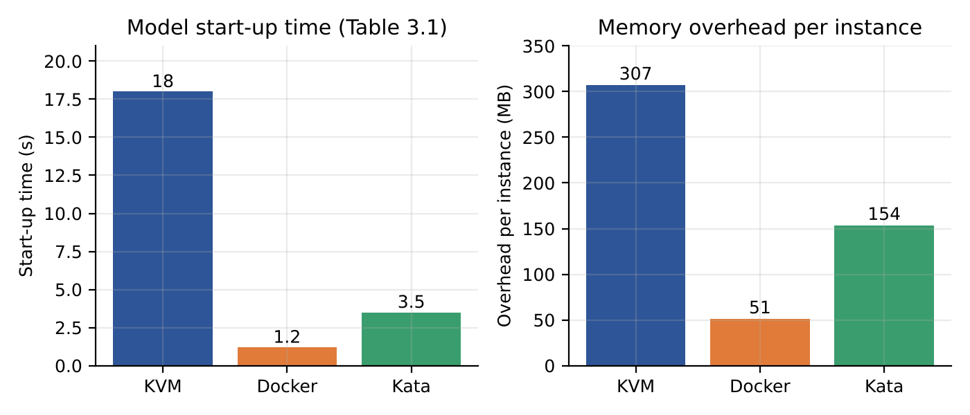
Figure 1.4: Model start-up time and per-instance memory overhead (constants from Table 3.1, assumed values)

1.8 Suitability of each approach for EduCloud workloads
The table below connects the characterisation to the concrete EduCloud tenants listed in the scenario. A rating of Strong means the approach is the natural choice, Possible means it works with extra controls, and Poor means it conflicts with a stated requirement.
EduCloud workload | Key requirement | A. KVM/QEMU | B. Docker | C. Kata
Student Information System (SIS) | Strong isolation, live migration, high availability | Strong | Poor (shared kernel, no live migration) | Possible (no live migration)
Learning Management System (LMS) | Elastic web tier, fast scaling | Possible | Strong for stateless tiers | Possible
Examination portal | Integrity of results, predictable latency at peak | Strong | Possible if hardened | Possible
Departmental research | Cheap, dense, trusted tenants | Possible | Strong | Possible
External Spark/Hadoop (Day 4) | Untrusted code, heavy I/O, long jobs | Possible (heavier to operate) | Poor (shared kernel) | Strong
Table 1.1: Qualitative suitability matrix (judgement based on Tasks 1 to 6).

1.9 Why paravirtual drivers (virtio) belong inside approach A
The brief lists hardware-assisted virtualization and paravirtualization as one candidate pair. In practice they are combined: the CPU is virtualized with hardware extensions (VMX, EPT), while I/O uses paravirtual virtio drivers because emulating a real disk or network card instruction by instruction would cause a VM exit for almost every register access. A virtio queue replaces dozens of exits per packet with one notification per batch. This is why the exit-rate constant used in Task 3 (f = 5,000 + 0.5 per I/O operation) is low compared with fully emulated devices, and it is also why switching from emulated e1000 and IDE devices to virtio is usually the first tuning step on a slow VM. Because virtio is a driver choice rather than a different isolation architecture, it is treated here as part of approach A and not as a fourth approach.

Task 2: Identify the Dominant Overhead Source
Approach | Dominant overhead | Where it occurs | How it scales
A. KVM/QEMU | VM exits (traps) from privileged instructions, interrupts and virtio notifications | Between guest and KVM on every vCPU; each exit saves/restores guest state and may bounce to QEMU | Cost per exit is fixed, but exit rate grows with I/O rate and with the number of vCPUs competing, because more context switches and interrupts occur
B. Docker | Virtual network path: veth, bridge and netfilter connection tracking | Host kernel network stack, per packet, in softirq context | Rises with packet rate and with the number of containers (more iptables rules, larger conntrack table); CPU ‘native’ so no exit penalty
C. Kata | Virtual I/O across the VM boundary (virtio-fs / virtio-net notifications and exits) | Shim ↔ guest agent and the host side of virtio queues | Grows with small-file and small-packet I/O rates; each pod adds a VMM process and extra guest kernel work

Why these are the right focus. In A, the guest executes at near-native speed until it does something privileged, so the exit count, not instruction speed, decides performance. At 25,000 exits per second per vCPU the lost time is 25,000 × 1.5 µs = 3.75% of a vCPU, and the figure rises with I/O. In B there is no hypervisor and system calls cost the native 0.2 µs, so the only added work is in the virtual network and storage layers, which is where container latency actually accumulates in practice. In C, the VM boundary adds exits like A, but the paths that stand out are the shared-filesystem and network channels, because container images are shared into the guest across that boundary.
Scaling behaviour. As co-located instances increase, A’s exits compete for the same physical cores, so exit handling and scheduling delay both grow; B’s softirq load grows with packet rate until it saturates one or more cores; C behaves like A but with a lower exit rate per instance because the micro-VM guest is minimal.
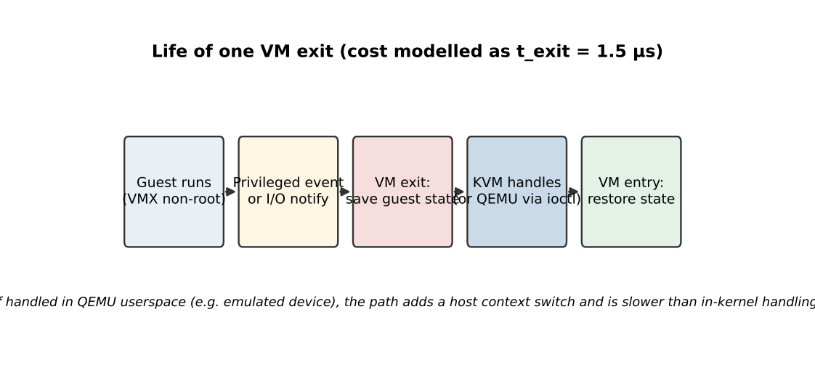
Figure 2.1: Sequence of a VM exit and the point where cost is incurred

2.2 Relating the overhead to architecture behaviour

A. KVM/QEMU: exits
Every guest I/O request ends in a notification to the host (a doorbell write), which is a VM exit. The exit rate can be written as f = f_base + a × IOPS, where f_base covers timer interrupts, HLT and IPIs, and a is the number of exits caused per I/O operation. With a = 0.5 (virtio batches notifications), f_base = 5,000/s and 40,000 I/O operations per second per vCPU, f = 5,000 + 20,000 = 25,000 exits/s, which is the value used in the model. The cost therefore rises linearly with the I/O rate, and at higher co-location the host also spends time on exits for other vCPUs, which delays the return of each exit to its guest. Features such as posted interrupts, vhost and event-index notification suppression reduce a and are valid tuning directions.

B. Docker: virtual network processing
A container’s CPU work and system calls run natively, so the dominant cost is what lies between the application and the wire. At 25 Gbps with 1,500-byte frames the packet rate is 25 × 10^9 / (1500 × 8) ≈ 2.08 million packets per second. If bridge, veth and netfilter processing cost an assumed 1.2 µs of CPU per packet, the host spends 2.08 × 10^6 × 1.2 × 10^-6 ≈ 2.5 cores just forwarding at line rate. With 9,000-byte jumbo frames the rate falls to 0.35 Mpps and the cost to about 0.42 cores, a six-fold reduction. Conntrack table lookups also grow with the number of connections, which is why container density mostly harms the tail of the latency distribution first.
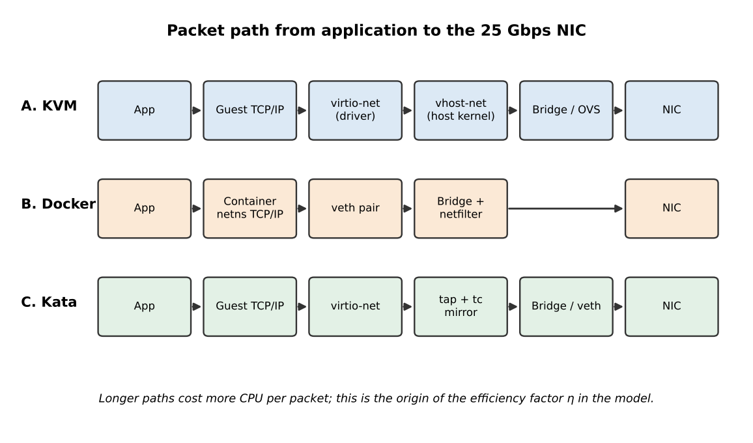
Figure 2.2: Packet path in each approach; more hops mean lower efficiency η

C. Kata: I/O across the micro-VM boundary
Kata containers read their image layers through virtio-fs and send packets through a tap device to virtio-net. Each small file operation or packet notification may cross the VM boundary; with an assumed 18,000 exits per second per vCPU the exit loss is 18,000 × 1.5 µs = 2.7% of a vCPU. Small-file metadata workloads (such as Hadoop’s many small files) are the most expensive pattern because every metadata call is a round trip to the host-side virtiofsd daemon. Large sequential reads are much cheaper because they are batched.

2.3 Summary of scaling behaviour
Approach | Cost per event | Event rate depends on | Effect of more co-located instances
A. KVM | 1.5 µs per exit | I/O rate, timers, interrupts | Exit handling and scheduling delay both increase; steal time grows with R
B. Docker | ≈1.2 µs per packet (assumed) | Packet rate and connection count | Softirq saturates cores; conntrack and iptables chains lengthen
C. Kata | 1.5 µs per exit plus virtiofs round trip | Small-file and small-packet rate | Per-pod VMM and daemon load adds up; exits scale like A

2.4 Exit cost for different guest profiles
Using the relation f = 5,000 + 0.5 x IOPS from section 2.2 with t_exit = 1.5 µs, the time lost to exits depends strongly on what the guest is doing. The table gives four representative profiles.
Guest profile | I/O ops per second per vCPU | Exits per second (f) | vCPU time lost (f x t_exit)
Idle management VM | 0 | 5,000 | 0.75%
Light web server | 10,000 | 10,000 | 1.50%
Registration-week web/database VM | 40,000 | 25,000 | 3.75%
I/O-heavy database VM | 80,000 | 45,000 | 6.75%
Table 2.1: Exit overhead by guest profile (model estimate).
An idle VM loses under 1% of a vCPU, while an I/O-heavy database VM loses almost 7%. The overhead is therefore not a fixed tax on virtualization but a property of the workload, which is why the registration-week load, dominated by small database transactions, is the case to study.

2.5 Packet-processing cost for Docker at different frame sizes
The same line-rate calculation used in section 2.2 can be repeated for other frame sizes. Smaller frames mean more packets for the same bandwidth, and the per-packet cost is the quantity the bridge, veth and netfilter path actually charges.
Frame size (bytes) | Packet rate (Mpps) | CPU cores at 1.2 µs per packet | Share of a 64-core host
512 | 6.10 | 7.32 | 11.4%
1500 | 2.08 | 2.50 | 3.9%
4000 | 0.78 | 0.94 | 1.5%
9000 | 0.35 | 0.42 | 0.7%
Table 2.2: Forwarding cost at 25 Gbps line rate (model estimate).
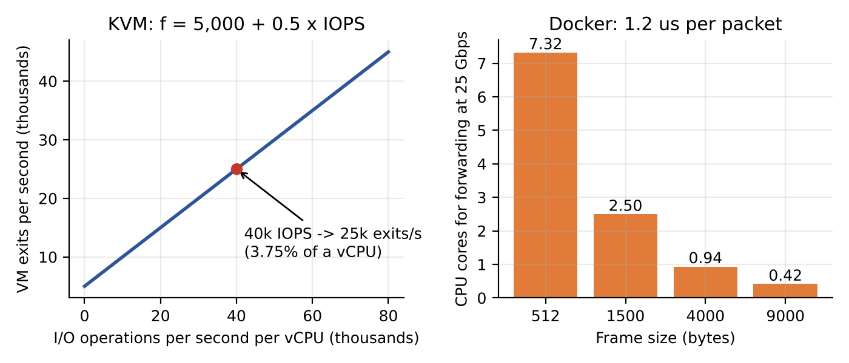
Figure 2.3: Left: VM-exit rate against I/O rate for KVM. Right: Docker forwarding cost against frame size (model)
Figure 2.3 summarises both relations. The left panel is linear because each additional I/O operation adds half an exit, and the right panel falls steeply because jumbo frames cut the packet count. Two practical consequences follow: enabling jumbo frames on the storage and migration networks is an inexpensive way to release CPU, and the virtual-switch path for containers should be measured with small-packet traffic, since that is where the model predicts the highest cost.

2.6 Techniques that reduce each dominant overhead
Approach | Dominant overhead | Technique | Why it helps
A. KVM/QEMU | VM exits | Posted interrupts, vhost-net, virtio multiqueue, hugepages | Fewer exits per I/O, shorter exit handling and fewer EPT misses
B. Docker | Virtual network path | Jumbo frames, host networking for trusted services, reduced conntrack scope, eBPF-based datapaths | Fewer packets or fewer hops per packet
C. Kata | Cross-boundary I/O | Block devices instead of virtio-fs for large data, larger I/O sizes, vhost-user networking | Batches work and removes the host-side user-space round trip
Table 2.3: Overhead-reduction techniques (qualitative).

Task 3: Build a Quantitative Performance Model
Table 3.1 lists the assumed constants for the model. Values for t_exit, t_syscall, core count, RAM, VM memory and line rate come from the brief.
Approach | Exits per vCPU-s (f) | Sched. penalty γ per +1 R | Memory overhead per instance (GB) | Net efficiency η | KSM saving | Start-up (s)
A. KVM/QEMU | 25,000 | 0.008 | 0.30 | 0.92 | 12% | ≈18
B. Docker | 0 | 0.005 | 0.05 | 0.88 | 0% | ≈1.2
C. Kata | 18,000 | 0.006 | 0.15 | 0.85 | 0% | ≈3.5
Table 3.1: Assumed model constants (estimates to be validated in Task 8–10).

3.1 CPU model
Let R be the vCPU:pCPU overcommit ratio. When all vCPUs are runnable, each receives 1/R of a physical core; the steal time fraction is therefore s = 1 − 1/R. Virtualization overhead has a fixed part from VM exits, o_v = f · t_exit, and a part that grows with contention (extra context switches, cache pollution), γ(R − 1). The effective capacity per busy vCPU, in physical-core equivalents, is:
C(R) = (1/R) · [1 − f·t_exit − γ(R − 1)]
Worked example, KVM at R = 4: o_v = 25,000 × 1.5 µs = 0.0375; contention term = 0.008 × 3 = 0.024; total overhead 6.15%; C(4) = 0.25 × 0.9385 = 0.235 pCPU. Steal time is 1 − 0.25 = 75% of wall-clock per vCPU. For Docker at R = 4: overhead = 0.005 × 3 = 1.5%, so C(4) = 0.246. Kata at R = 4: 0.0270 + 0.018 = 4.5%, C(4) = 0.239. At R = 8 the overhead is 9.3% (KVM), 3.5% (Docker) and 6.9% (Kata).
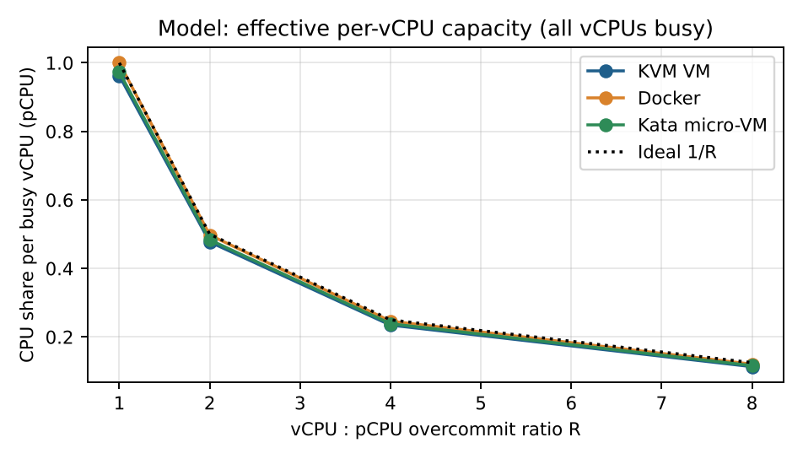
Figure 3.1: Model-predicted per-vCPU capacity versus overcommit ratio
System-call cost is not a differentiator here: containers pay the native 0.2 µs per call, while a VM guest also executes system calls natively because they do not trap. Interception (as in gVisor) would add roughly one exit-sized cost, 1.5 µs, giving 7.5× the native cost per call, which is why gVisor was not selected.

3.2 Memory model
Guest-usable memory is M_use = 512 − 16 = 496 GB. With guest size m = 8 GB, per-instance overhead m_o and page-sharing saving σ, the maximum number of instances before ballooning, swapping or sharing must be used is:
N_max = floor( M_use / (m + m_o) ) with sharing: floor( M_use / (m(1 − σ) + m_o) )
KVM: 496 / 8.30 = 59.8, so 59 VMs; with 12% KSM sharing, 496 / 7.34 = 67 VMs. Docker: 496 / 8.05 = 61. Kata: 496 / 8.15 = 60. Memory overcommit beyond N_max forces ballooning or swap. Swap penalty example: with RAM latency 100 ns, NVMe swap 100 µs and a major-fault probability p = 0.1%, average access time = 0.999 × 100 ns + 0.001 × 100,000 ns ≈ 200 ns, so memory access becomes about twice as slow even at a tiny fault rate.

3.3 I/O and network model
If n instances actively share one NIC of line rate L = 25 Gbps, with path efficiency η, the fair-share throughput per instance is:
T(n) = η · L / n
For n = 8: KVM 0.92 × 25 / 8 = 2.88 Gbps, Docker 2.75 Gbps, Kata 2.66 Gbps. A single instance gets 23.0, 22.0 and 21.3 Gbps respectively. SR-IOV (used later in Task 12) raises η to about 0.98 by bypassing the software switch.
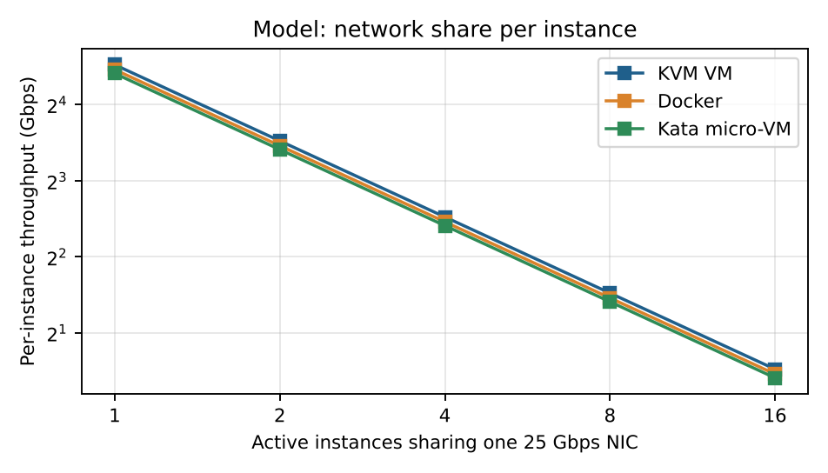
Figure 3.2: Model-predicted network share per instance

3.4 Density model
For the service target of at most 10% degradation, solve o(R) = o_v + γ(R − 1) ≤ 0.10, giving R* = 1 + (0.10 − o_v)/γ. The CPU-limited density for 4-vCPU guests is floor(64 R* / 4).
Approach | o_v | R* | CPU-limited instances | Memory-limited instances | Binding limit
A. KVM/QEMU | 3.75% | 8.8 | 141 | 59 (67 with KSM) | Memory
B. Docker | 0% | 21.0 | 336 | 61 | Memory
C. Kata | 2.7% | 13.2 | 210 | 60 | Memory
Table 3.2: Model-predicted per-host density bounds.
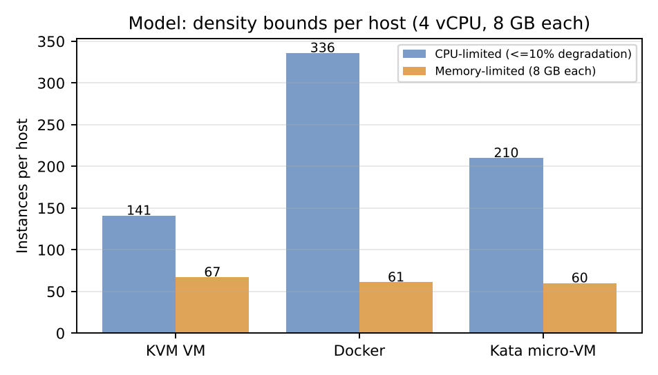
Figure 3.3: CPU-limited versus memory-limited density
Interpretation: with 8 GB guests the host runs out of memory long before the CPU reaches the 10% degradation limit, so 59–67 instances per host is the practical ceiling for all three approaches. Density gains must therefore come from right-sizing guest memory, page sharing, or fewer idle guests, not from CPU overcommit.

3.5 Full CPU model grid
Table 3.3 evaluates C(R) = (1/R)(1 − f·t_exit − γ(R − 1)) for every overcommit ratio in the brief. Steal time is the fraction of time a runnable vCPU waits for a physical core.
Approach | R | Overhead (%) | C(R), pCPU per busy vCPU | Steal time (%)
KVM VM | 1:1 | 3.75 | 0.963 | 0.0
KVM VM | 2:1 | 4.55 | 0.477 | 50.0
KVM VM | 4:1 | 6.15 | 0.235 | 75.0
KVM VM | 8:1 | 9.35 | 0.113 | 87.5
Docker | 1:1 | 0.0 | 1.0 | 0.0
Docker | 2:1 | 0.5 | 0.497 | 50.0
Docker | 4:1 | 1.5 | 0.246 | 75.0
Docker | 8:1 | 3.5 | 0.121 | 87.5
Kata micro-VM | 1:1 | 2.7 | 0.973 | 0.0
Kata micro-VM | 2:1 | 3.3 | 0.483 | 50.0
Kata micro-VM | 4:1 | 4.5 | 0.239 | 75.0
Kata micro-VM | 8:1 | 6.9 | 0.116 | 87.5
Table 3.3: CPU model grid (model estimates).
Reading the table: at R = 1 there is no steal time and only exit overhead matters, so Docker leads (0%) and KVM trails (3.75%). As R increases the share per vCPU falls as 1/R, so every approach loses most of its capacity to sharing, not to virtualization; the virtualization overhead is the small difference between the ideal 1/R and the achieved value. For example at R = 8, ideal 0.125 against KVM 0.113, which is 9.4% lower.

3.6 Storage I/O model
Using the same fair-share reasoning for the NVMe device, let the device deliver IOPS_dev = 500,000 4-KB random-read operations per second (assumed). With n active instances and path efficiency η_io, each gets IOPS(n) = η_io × IOPS_dev / n. Assumed η_io values are 0.80 for KVM (virtio-blk through QEMU), 0.95 for Docker (direct host filesystem) and 0.75 for Kata (virtio-fs and extra copies).
Approach | n = 1 | n = 2 | n = 4 | n = 8 | n = 16
A. KVM (η_io 0.80) | 400,000 | 200,000 | 100,000 | 50,000 | 25,000
B. Docker (η_io 0.95) | 475,000 | 237,500 | 118,750 | 59,375 | 29,688
C. Kata (η_io 0.75) | 375,000 | 187,500 | 93,750 | 46,875 | 23,438
Table 3.4: Model-predicted IOPS per instance (model estimates).

3.7 Network model grid
Approach (η) | n = 1 | n = 2 | n = 4 | n = 8 | n = 16
A. KVM (0.92) | 23.00 | 11.50 | 5.75 | 2.88 | 1.44
B. Docker (0.88) | 22.00 | 11.00 | 5.50 | 2.75 | 1.38
C. Kata (0.85) | 21.25 | 10.63 | 5.31 | 2.66 | 1.33
SR-IOV (0.98) | 24.50 | 12.25 | 6.13 | 3.06 | 1.53
Table 3.5: Model-predicted network throughput per instance in Gbps.

3.8 Response-time model
Throughput alone does not describe what users saw in registration week, so a simple queueing approximation is added. Treat each physical core as a single server with mean service time S per request. With utilisation ρ the mean response time of an M/M/1 queue is W = S / (1 − ρ). With S = 10 ms: at ρ = 0.20 (normal load) W = 12.5 ms; at ρ = 0.60 W = 25 ms; at ρ = 0.78 W = 45 ms; at ρ = 0.90 W = 100 ms. The response time doubles when utilisation passes 60% and rises steeply beyond 80%, which explains the slow response and failed logins in the scenario: with a 3× load increase the SIS hosts moved into the steep part of the curve. Virtualization overhead slightly raises ρ (for example 3.75% for KVM), which matters most when the system is already close to saturation.

3.9 Sensitivity analysis
Because the constants are assumptions, it is important to know how strongly the density conclusion depends on them. Figure 3.4 shows that R* (the maximum overcommit at 10% degradation) falls quickly when the exit rate rises or the contention penalty γ is larger. For KVM with γ = 0.008, doubling the exit rate from 25,000 to 50,000 per second lowers R* from 8.8 to about 4.1, because o_v becomes 7.5%. This means exit-rate measurements (from perf kvm_exit counts in Task 8) are the single most valuable calibration for the model.
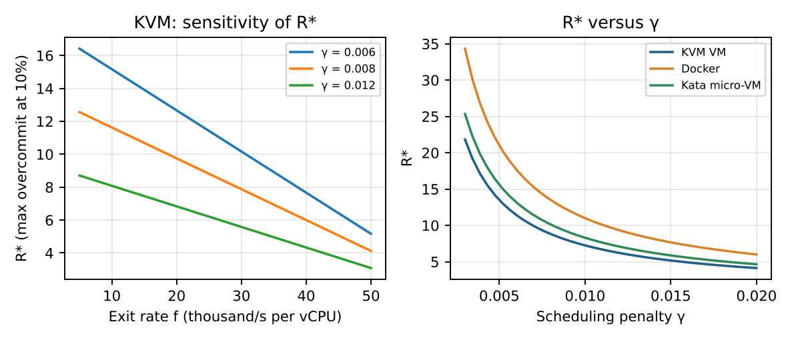
Figure 3.4: Sensitivity of maximum overcommit R* to exit rate and scheduling penalty

3.10 Justification of assumptions
Assumption | Value | Justification
Host reserve | 16 GB | Host kernel, hypervisor, page tables and management agents need memory that guests cannot use.
Guest vCPU count | 4 | Typical for SIS/LMS application servers in a university; keeps R meaningful.
Exit rate (KVM) | 25,000 / s / vCPU | Plausible for an I/O-active web/database guest with virtio; to be replaced with perf measurements.
γ (contention penalty) | 0.005–0.008 | Represents extra context switches and cache loss per additional vCPU per pCPU.
Network efficiency η | 0.85–0.92 | Reflects software forwarding cost relative to line rate; SR-IOV is near native.
NVMe device capability | 500,000 IOPS | Typical enterprise NVMe 4-KB random read performance class.

3.11 Memory budget at maximum density
Figure 3.5 turns the N_max calculation of section 3.2 into a picture of the 512 GB host. Every approach reaches roughly the same ceiling because the 8 GB guest allocation dominates and the per-instance overhead (0.05 to 0.30 GB) is small beside it. KVM carries the largest overhead per instance, which costs it one instance compared with Docker, and KSM page sharing is the only lever in the model that raises the ceiling noticeably (67 instances).
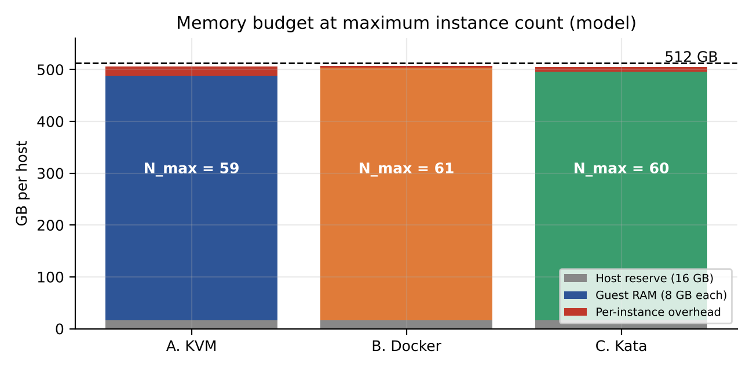
Figure 3.5: Memory budget of one 512 GB host at the model maximum instance count

3.12 Storage and network share per instance
Tables 3.4 and 3.5 give the numbers; Figures 3.6 and 3.7 show the shape. Both follow a 1/n law, so on a log-log plot they are straight lines with the same slope for every approach. The approaches differ only in the vertical offset set by the path efficiency (eta_io or eta). The practical lesson is that adding instances divides a fixed device budget, and no virtualization choice can remove this: only more devices, a faster path such as SR-IOV, or admission control can.
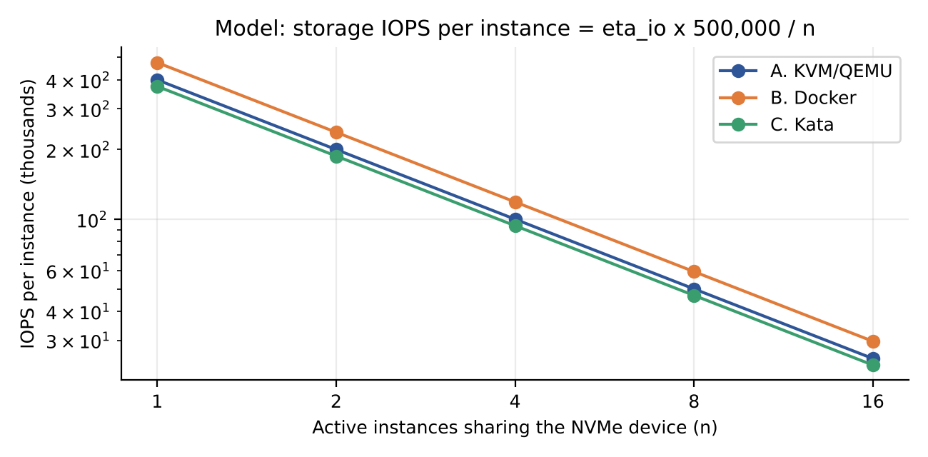
Figure 3.6: Model-predicted NVMe IOPS per instance (log-log axes)
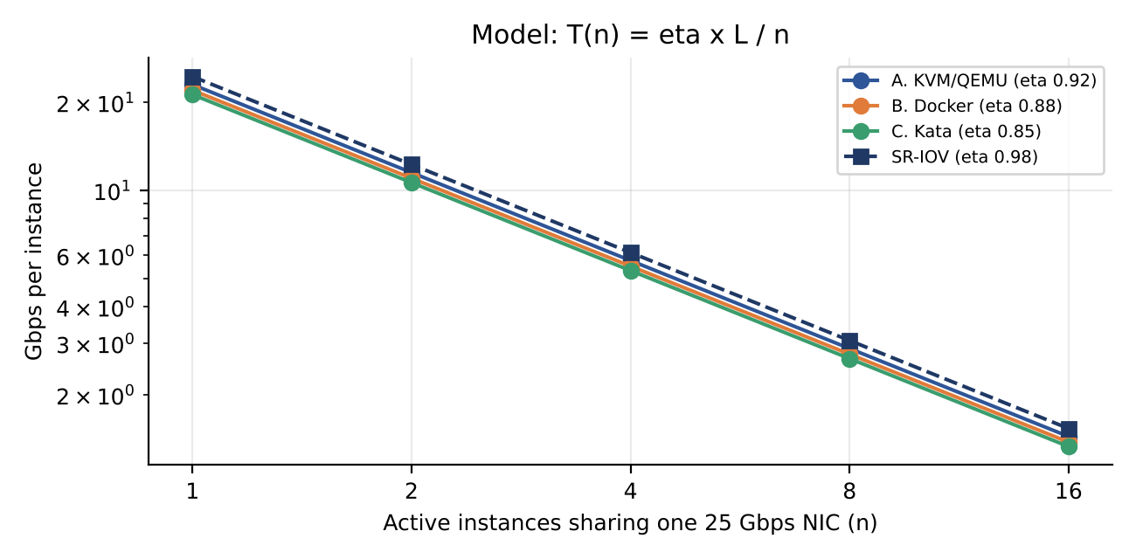
Figure 3.7: Model-predicted network throughput per instance, including SR-IOV (log-log axes)
At 16 co-located instances the fair share of one NIC is only about 1.4 Gbps in every software-switched approach, which is below what a Spark executor needs during a shuffle. This foreshadows the Day-4 decision to give the external pool SR-IOV and its own NICs.

3.13 Response-time curve
Section 3.8 quoted four points on the M/M/1 curve. Figure 3.8 draws the whole curve and marks them. The curve is nearly flat up to about 50% utilisation and then bends sharply upward, so a modest rise in load near the knee has a large effect on what users experience. The 70% planning target used in Tasks 6 and 12 sits just before the steepest part of the curve.
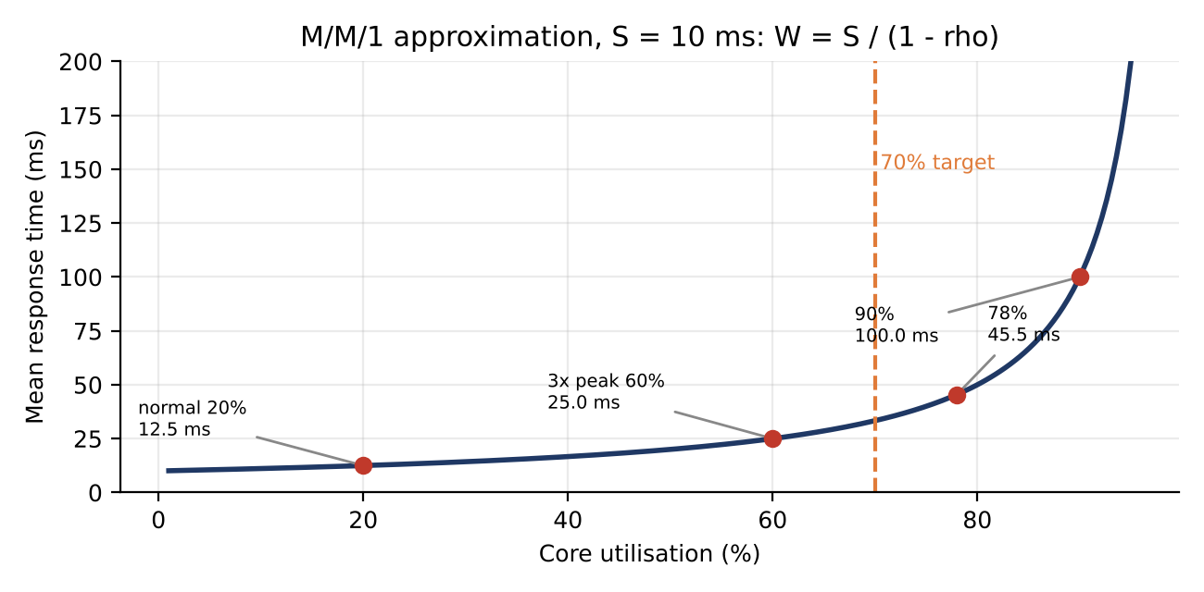
Figure 3.8: M/M/1 mean response time against core utilisation, with the points used in section 3.8 (model)

3.14 Applying the model to today's EduCloud
The model can now be used to explain the registration-week failures in the scenario. Today EduCloud runs about 400 VMs on 16 hosts, which is 25 VMs per host. With 4 vCPUs each that is 100 vCPUs on 64 cores, so R = 100/64 = 1.56. Memory use is 25 x 8 = 200 GB of the 496 GB available, about 40%, so memory is not the problem. For KVM the overhead at this R is o = 3.75% + 0.8% x 0.56 = 4.2%, and the usable capacity per core is 1 - 0.042 = 0.958.
What matters is the fraction b of vCPUs that are busy at the same moment. The core utilisation is rho = 100 x b / (64 x 0.958). The table evaluates this for four assumed values of b at normal load and at the 3x registration peak, with the M/M/1 response time for S = 10 ms.
Busy fraction b of vCPUs | Utilisation, normal | Response time, normal | Utilisation, 3x peak | Response time, 3x peak
10% | 16% | 12 ms | 49% | 20 ms
15% | 24% | 13 ms | 73% | 38 ms
20% | 33% | 15 ms | 98% | 467 ms
25% | 41% | 17 ms | 122% | unstable (rho >= 1)
Table 3.6: Model estimate for the current 16-host EduCloud (assumed b; M/M/1 with S = 10 ms).
If about 15% of vCPUs are busy in normal weeks, the cluster average is comfortable (about 25% utilisation), and tripling the demand moves it to about 73%, already above the 70% target. At 20% it reaches saturation. Real load is also uneven across hosts, so some hosts hit these limits before the average does, and a noisy neighbour or a live migration at the same moment removes further capacity. This matches the slow responses and failed logins reported in the scenario and shows that the problem is a capacity-planning and placement problem, not a failure of virtualization itself. The values of b are assumptions and should be replaced with monitoring data.

3.15 Summary of model outputs
Question | A. KVM/QEMU | B. Docker | C. Kata | Where derived
Overhead at R = 4 | 6.15% | 1.5% | 4.5% | Table 3.3
Maximum R at 10% degradation (R*) | 8.8 | 21.0 | 13.2 | Table 3.2
Instances per host, memory-bound (8 GB) | 59 (67 with KSM) | 61 | 60 | Section 3.2
Network per instance at n = 8 | 2.88 Gbps | 2.75 Gbps | 2.66 Gbps | Table 3.5
Storage per instance at n = 8 | 50,000 IOPS | 59,375 IOPS | 46,875 IOPS | Table 3.4
Start-up time (assumed) | about 18 s | about 1.2 s | about 3.5 s | Table 3.1
Table 3.7: Compact summary of the Task 3 model.

Task 4: Analyse Performance Under Different Operating Conditions

Best case
The best case is a CPU-bound, cache-friendly workload with large pages, R ≤ 2, vCPUs pinned to cores within one NUMA node, and almost no I/O. In KVM the guest rarely leaves non-root mode, so exits stay far below 25,000/s and overhead approaches the 0.5% contention term at R = 2 (C(2) ≈ 0.477 against an ideal 0.5). Docker is essentially native here (0.497). Kata matches KVM. Latency is unaffected and throughput is within about 1–4% of bare metal.

Typical case: registration-week web and database load
A mix of short HTTP requests and database transactions generates many small network packets and fsyncs. In KVM, each virtio notification causes an exit; at 25,000 exits/s the model loses 3.75% of a vCPU, and at R = 4 the total is 6.2%, still below the target. In Docker the cost shifts to netfilter and conntrack: as connection counts climb, per-packet processing rises and tail latency (95th percentile) widens before the mean does. In Kata the virtio-fs and virtio-net paths add a small fixed latency per I/O. For all three, queueing at the vCPU is the bigger effect: at R = 4 each busy vCPU waits about 75% of the time, so response time depends more on the scheduler than on the virtualization layer.

Worst case
- Noisy neighbour: a CPU or I/O hog in one guest. In KVM and Kata, the hog consumes the vCPU quota and host softirq capacity; steal time in other guests rises and cache and memory bandwidth are shared. In Docker, the shared kernel means a fork bomb, a memory-hungry process or heavy I/O can also stress the kernel’s global structures unless cgroup limits are set, so interference can be broader.
- Memory overcommit with swapping: beyond 59–67 instances per host, ballooning and then swap start. As computed in Task 3, even a 0.1% major-fault rate doubles average memory access time and also adds I/O load on the same NVMe used for guest disks.
- Live migration during peak: pre-copy migration of an 8 GB VM over 25 Gbps (3.125 GB/s) with a dirty rate D takes about T = V/(B − D). If D = 1 GB/s then T ≈ 8/2.125 ≈ 3.8 s; if D = 3 GB/s, T ≈ 64 s and the migration may never converge unless auto-converge or post-copy is used. The migration also consumes NIC bandwidth, cutting T(n) for co-located VMs. Containers cannot be live-migrated natively and are restarted instead.
- I/O storm: a batch job saturating the NVMe queue raises the p95 latency of every tenant using the same device, in all three approaches, unless I/O limits (cgroup io.max, QEMU throttle) or separate devices are used.

4.5 Summary matrix
Condition | A. KVM/QEMU | B. Docker | C. Kata
Best | ≈4.5% overhead at R = 2; hugepages and pinning minimise EPT misses | ≈0.5% at R = 2; near native | ≈3.3% at R = 2; small footprint
Typical (registration) | ≈6% at R = 4; p95 affected by exits and run-queue wait | ≈1.5% at R = 4; tail latency rises with conntrack load | ≈4.5% at R = 4; small extra latency per I/O
Worst: noisy neighbour | Steal time and cache contention; mitigated by pinning and quotas | Broadest impact; shared kernel and page cache | Contained like KVM; host virtiofsd is a shared point
Worst: memory overcommit | Ballooning/swap; 2× slower memory at 0.1% faults | OOM-killer risk; cgroup limits needed | Like KVM, with extra guest kernel memory
Worst: migration at peak | Pre-copy competes for bandwidth; may fail to converge | Not applicable: restart (brief outage) | Typically restart
Worst: I/O storm | Device queue shared; use QEMU throttling | Use cgroup io.max | Throttle in VMM and virtiofsd

4.6 What happens inside the virtualization layer
In the best case the hypervisor is almost idle: vCPUs stay in guest mode, EPT entries are cached in the TLB, and device notifications are batched. The layer contributes only timer and housekeeping exits. In the typical case, bursts of short requests increase interrupts and virtio notifications, so exits and host softirqs rise, run-queues lengthen and the scheduler time-slices vCPUs. In the worst case the layer itself becomes the bottleneck: the host kernel runs out of runnable CPU for I/O threads (vhost, QEMU iothreads), queue depths in virtio rings grow, and the guest sees steal time and timer drift. Latency rises first, because requests wait in queues, then throughput falls once queues saturate.

4.7 Memory pressure and live migration in detail
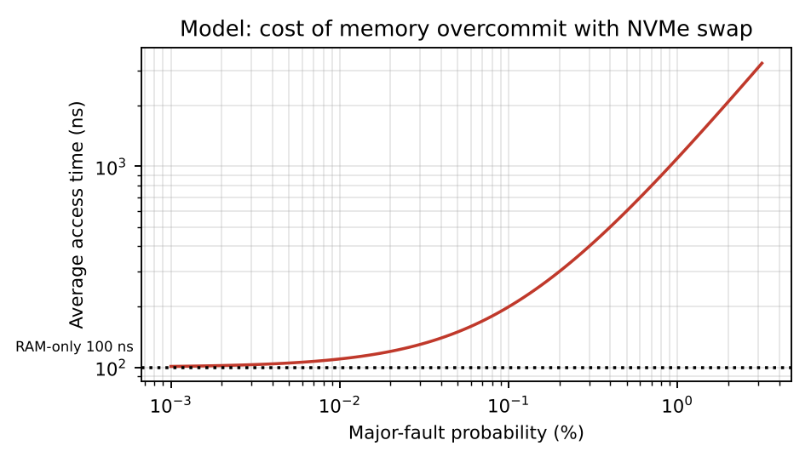
Figure 4.1: Average memory access time against major-fault probability
Figure 4.1 shows why memory overcommit is dangerous: average access time is about 200 ns at a 0.1% fault probability (twice RAM speed) and about 1.1 µs at 1%. A 1% major-fault rate is therefore about eleven times slower than RAM-only. Ballooning avoids this by reclaiming idle guest pages first, but only if the guest has idle memory to give.
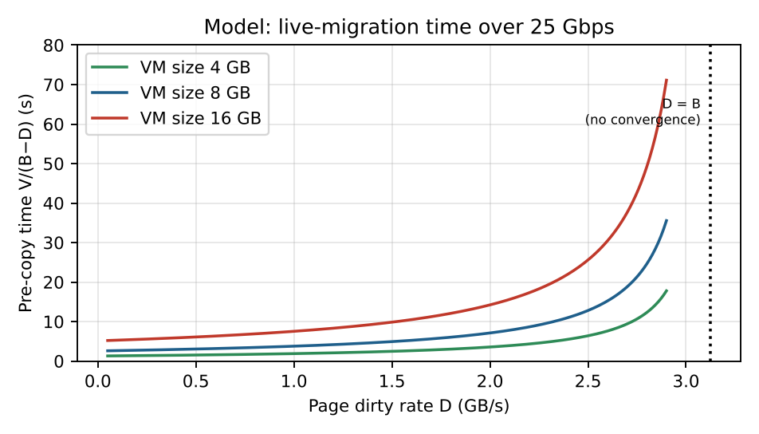
Figure 4.2: Pre-copy migration time for several VM sizes against dirty-page rate
Figure 4.2 shows the migration time rising sharply as the dirty rate approaches the available bandwidth. For an 8 GB VM at D = 2 GB/s the pre-copy needs about 7.1 s; at D = 3 GB/s about 64 s. Hosts being patched during registration week would run hot VMs with high dirty rates, so migrations should be done outside peak or use auto-converge (which throttles the guest) or post-copy.

4.8 Decomposing the overhead
Figure 4.3 splits the Task 3 overhead into its two terms. The blue part is the exit overhead (f x t_exit), which does not change with overcommit; the orange part is the contention term gamma(R - 1), which grows with R. At R = 1 only the blue part exists, so Docker has no overhead and KVM and Kata pay for their exits. As R rises the orange part dominates for every approach, and KVM is the first to approach the 10% line at R = 8 (9.35%). This confirms the reading of Table 3.3 that sharing, not virtualization, takes most of each vCPU at high overcommit.
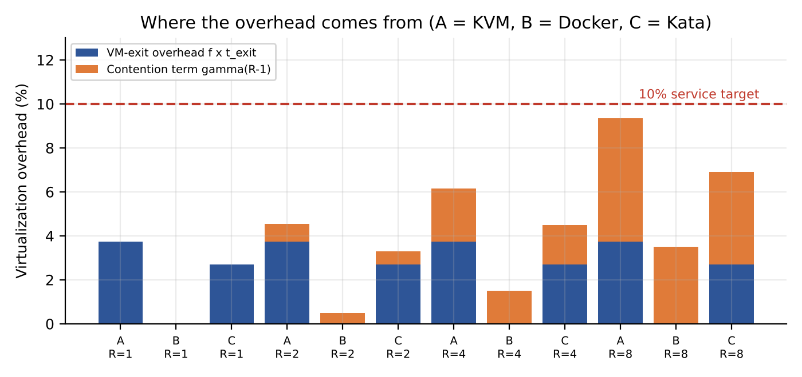
Figure 4.3: Decomposition of the modelled virtualization overhead by approach and overcommit ratio

4.9 Migration time for larger VMs
Figure 4.2 showed pre-copy migration time for several VM sizes. The table below gives the underlying numbers from T = V / (B - D) with B = 3.125 GB/s (25 Gbps). The extra rows matter for the SIS database, which may well have 16 or 32 GB of memory.
VM memory | D = 1 GB/s | D = 2 GB/s | D = 3 GB/s
8 GB | 3.8 s | 7.1 s | 64.0 s
16 GB | 7.5 s | 14.2 s | 128.0 s
32 GB | 15.1 s | 28.4 s | 256.0 s
Table 4.1: Modelled pre-copy migration time (model estimate; D is the dirty-page rate).
When the dirty rate approaches the link bandwidth the time grows without bound, and at D = 3 GB/s a 32 GB VM would need over four minutes of continuous copying while also competing with user traffic for the NIC. Three levers follow from the formula: increase B (dedicated migration network), reduce D (auto-converge throttles the guest) or reduce the amount that must converge (post-copy). For this reason the policy in Task 12 forbids migrations during the registration peak.

4.10 What users experience under each condition
The internal behaviour of the virtualization layer translates into symptoms that operators and users can observe. The table links them, so that the monitoring plan in Task 11 can detect each condition early.
Condition | What happens in the layer | Symptom for a student | Metric that reveals it
Best case | Few exits, warm TLB and EPT, pinned vCPUs | Pages load normally | Low steal time, stable p95 latency
Typical registration load | More interrupts and virtio notifications, longer run queues | Slightly slower pages, occasional slow login | Rising exit rate, run-queue length and p95 latency
Noisy neighbour | Hog consumes CPU quota, cache and memory bandwidth | Random slow requests (high tail latency) | Steal time above about 5%, p99 spikes
Memory overcommit | Ballooning, then swap through the NVMe device | Timeouts, failed logins | Swap-in rate, major faults, memory pressure
Migration at peak | Pre-copy competes with user traffic, may not converge | Brief stalls during final switch-over | Migration duration, NIC utilisation
I/O storm | Shared device queue fills | All tenants slow, writes time out | Device queue depth, I/O wait
Table 4.2: Link between virtualization-layer behaviour and user-visible symptoms.

4.11 Controls that bound the worst case
- CPU: cgroup quotas or libvirt CPU shares for batch guests, vCPU pinning and NUMA-aware placement for latency-sensitive guests.
- Memory: admission control that refuses new guests beyond N_max, alert at 85% memory use, and guest ballooning only for guests with idle pages.
- Storage and network: QEMU block throttling, cgroup io.max, tc rate limiting and separate devices or VLANs for batch traffic.
- Operations: no live migration or patch windows during registration week, and a freeze rule that is checked automatically.

Task 5: Security Threat and Vulnerability Analysis
Attack surface by approach: A exposes the hypervisor (KVM), QEMU device emulation (large C code base), management plane, VM images/snapshots and the virtual network. B exposes the whole host kernel system-call interface (shared kernel), the container runtime and daemon socket, image registry and the bridge network. C exposes KVM and a smaller VMM, the shim/agent and the guest-to-host channels, but with a far smaller guest kernel and no shared host kernel for application system calls.
Threat | A: KVM | B: Docker | C: Kata | Reasoning and CIA impact on student records
VM / container escape | Low–Med | High | Low | Docker: one kernel bug gives host access, breaking confidentiality and integrity of every tenant. KVM: needs QEMU or KVM flaw. Kata: attacker must break guest kernel and then the VMM.
Cross-VM side channel (cache, SMT) | Medium | Medium–High | Medium | All share CPU caches. SMT siblings leak across tenants; hurts confidentiality of grades and IDs. VMs need SMT off or core pinning; containers share even more state.
Hypervisor / runtime vulnerability | Medium | High | Medium | Larger shared TCB in Docker (whole kernel). KVM and Kata rely on the smaller KVM + VMM TCB. Impact: integrity and availability.
VM sprawl / unpatched guests | High | Medium | Medium | Outdated guest kernels were found in the audit. In VMs each guest kernel needs separate patching; containers share the host kernel, so one host patch covers all, but images still age.
Image tampering | Medium | Medium–High | Medium | Uncontrolled image copying allows altered images with backdoors, affecting integrity. Docker’s layered registries make unsigned pulls easy to abuse.
Insecure live migration | High (if unencrypted) | N/A (restart) | Medium | Memory contents including secrets cross the network in clear text unless migration is encrypted, a confidentiality loss.
Virtual-network sniffing / spoofing | Medium | Medium–High | Medium | A shared bridge allows ARP spoofing unless micro-segmentation is applied. Impact: confidentiality and integrity.

Overall: Docker has the weakest isolation for mixed-trust tenants because of the shared kernel; KVM and Kata share the hardware-enforced boundary, with Kata reducing the guest attack surface. For availability, all three suffer from noisy-neighbour effects and failed migrations.
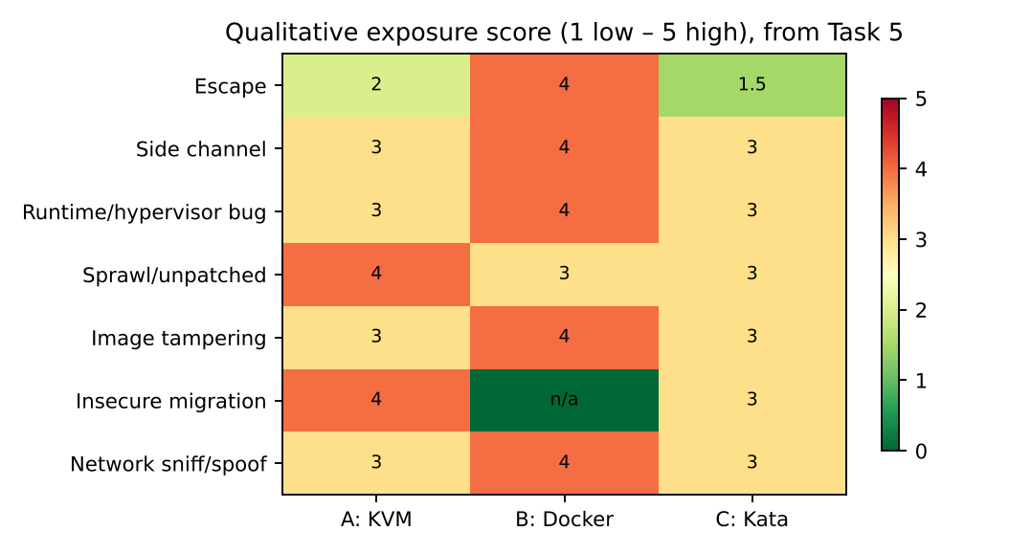
Figure 5.1: Heat-map of qualitative exposure by threat and approach

5.2 Threat model per approach

A. KVM/QEMU
- Entry points: a compromised guest application, a malicious tenant VM, a stolen management credential, a tampered image, or a network attacker on the virtual switch.
- Typical path: guest compromise → exploit in emulated device code in QEMU → code execution in the QEMU process → confinement by sVirt/SELinux limits lateral movement. A second step to the host kernel would be needed for full compromise.
- Strengths: hardware-enforced boundary and mature hardening. Weakness: guest kernel sprawl, because each VM carries its own OS that must be patched.

B. Docker
- Entry points: a compromised container application, a vulnerable image, an exposed Docker socket, or excessive capabilities granted to a container.
- Typical path: container compromise → kernel vulnerability or misconfiguration (privileged flag, host mounts) → root on the host → access to all containers on that host. There is no second boundary.
- Strengths: smaller attack surface per container, fast rebuilds, one host kernel to patch. Weakness: all tenants share fate with the host kernel.

C. Kata Containers
- Entry points: a compromised container, the guest kernel, the agent API, the shim, or the VMM.
- Typical path: container compromise → guest kernel exploit (contained inside the micro-VM) → VMM or KVM exploit to reach the host. Two serious bugs must be chained.
- Strengths: strong isolation with an unchanged container workflow. Weakness: more moving parts (shim, agent, VMM, virtiofsd) and less operational experience.

5.3 Impact on confidentiality, integrity and availability of student records
Impact | A. KVM | B. Docker | C. Kata
Confidentiality | Breach needs hypervisor/device escape or a side channel; moderate | A kernel escape exposes all tenants’ memory and volumes; high | Needs chained guest and VMM exploits; low–moderate
Integrity | Tampered images or unpatched guests alter records | Writable shared host paths and tampered images | Image tampering still applies; signed images help
Availability | Noisy neighbour, failed migrations, host failure | Kernel panic takes down every container on the host | As KVM, with additional runtime components to fail

5.4 Trust-boundary crossings
A useful way to compare approaches is to count how many distinct boundaries an attacker must cross from a tenant workload to student data on the host. In KVM: guest user → guest kernel → hypervisor/QEMU → host kernel (three crossings, with the first two inside the guest). In Docker: container user → host kernel (one crossing). In Kata: container user → guest kernel → VMM/KVM → host kernel (three crossings, plus namespaces inside the guest). This count is only a rough indicator, since the difficulty of each crossing varies, but it matches the exposure scores in Figure 5.1 and the isolation scores used in Task 6.

5.5 Attack paths and boundary crossings
Figure 5.2 draws the boundary-crossing argument of section 5.4. For Docker an attacker who gains code execution in a container needs one step, a kernel exploit or a misconfiguration, to reach the host and with it the data of every co-located tenant. For KVM and Kata the attacker must first compromise the guest kernel and then break out through the device-emulation or hypervisor layer, which is a narrower interface. Section 5.4 warns that the count is a rough indicator only, because the quality of each boundary matters as much as their number.
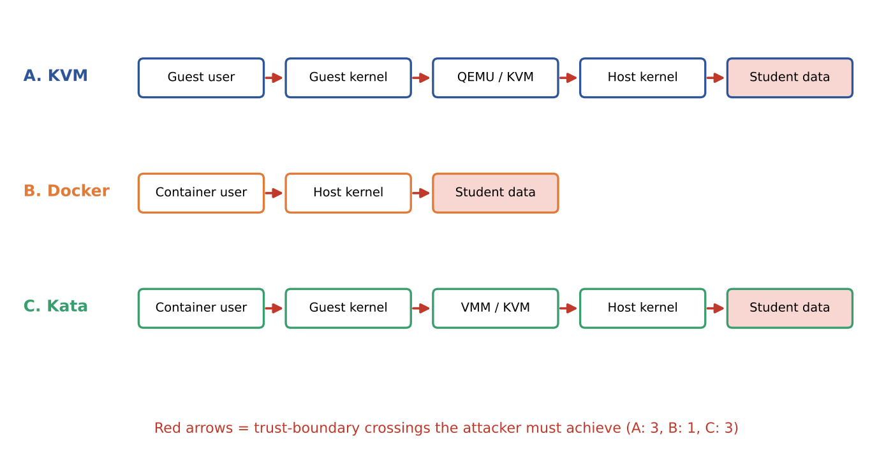
Figure 5.2: Boundary crossings from a tenant workload to student data (illustration of section 5.4)

5.6 Overall exposure summary
The qualitative ratings in the threat table can be turned into a rough numeric summary by mapping Low = 1, Low-Med = 1.5, Medium = 2, Medium-High = 2.5 and High = 3, and averaging across the threats that apply. The result, shown in Figure 5.3, is an unweighted mean and should only be read as an ordering: Docker is most exposed, KVM sits in the middle because of sprawl and unencrypted migration, and Kata is the least exposed. Insecure live migration is excluded for Docker because containers are restarted, not migrated.
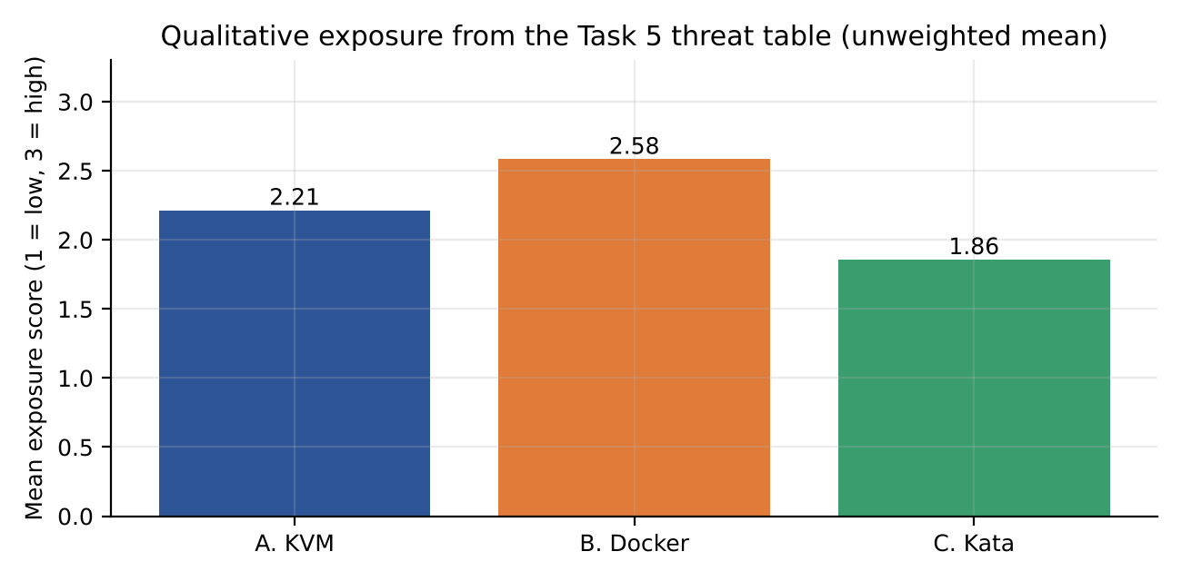
Figure 5.3: Mean exposure score derived from the qualitative ratings in the Task 5 threat table

5.7 STRIDE view of the EduCloud components
STRIDE category | EduCloud example | Component | Most exposed approach
Spoofing | ARP or DNS spoofing on a shared virtual bridge; stolen management credentials | Virtual network, management plane | B and A (shared bridge)
Tampering | Backdoored VM or container image copied between teams | Image store, snapshots | All; worst without signing
Repudiation | No audit trail of who created, copied or migrated a VM | Management plane | All
Information disclosure | Cache side channel, unencrypted migration, shared page cache | CPU caches, migration channel | A (migration), B (shared kernel state)
Denial of service | Noisy neighbour, I/O storm, failed migration at peak | Scheduler, NVMe queue, NIC | All; Docker broadest
Elevation of privilege | VM escape through device emulation; container escape through kernel bug | Hypervisor, host kernel | B (highest), A and C lower
Table 5.1: STRIDE mapping for EduCloud (qualitative).

5.8 From threat to control
Each threat found above is paired with the control chosen in Task 7, so that no identified risk is left without an owner.
Threat | Primary control | Secondary control | Evaluated in
VM or container escape | Hardware-isolated runtime (KVM, Kata); dedicated hosts for SIS | Patch quickly with live migration; sVirt/SELinux, seccomp | Tasks 7, 11
Cross-VM side channel | Dedicated hosts; SMT off for external pool | KPTI and CPU microcode mitigations | Task 7
VM sprawl, unpatched guests | Golden-image pipeline, image expiry | Vulnerability scanning of running guests | Task 11
Image tampering | Image signing and trusted registry | Admission policy that rejects unsigned images | Task 7
Insecure live migration | Encrypted migration on its own VLAN | Migration only inside the SIS pool | Tasks 7, 12
Network sniffing or spoofing | Micro-segmentation, default deny | Per-pool VLANs, ARP inspection | Tasks 7, 12
Table 5.2: Threat-to-control mapping.

Task 6: Formulate the Isolation–Performance Trade-off
Decision variables. For each tenant class k (SIS/LMS, internal research, external big-data): the approach a_k ∈ {KVM, Docker, Kata}; instances per host n_k; dedicated-host flag d_k ∈ {0,1}; SMT setting s_k ∈ {on, off}; and the number of hosts H_k.
Isolation score. From Task 5, define I(a, d, s) on a 1–5 scale: Docker 2; Docker with seccomp/AppArmor 3; KVM 4; Kata 4.5; KVM with SMT off 4.7; KVM on dedicated hosts 5. These scores are judgement-based and are justified by the threat table.
Objective. Minimise total cost:
Z = Σk [ c_h · H_k + λ · w_k · (5 − I_k) ]
where c_h is the cost of a host, w_k is the sensitivity weight of tenant k (SIS highest) and λ converts residual isolation risk into host-equivalents.
Constraints. (1) Degradation ≤ 10%: o_k(R) ≤ 0.10 from Task 3. (2) Memory: n_k × (m + m_o) ≤ 496 GB. (3) Isolation: I_SIS ≥ 4 and I_external ≥ 4. (4) Hosts: Σ H_k ≤ 16. (5) Peak utilisation ≤ 70% of usable capacity.
Example: an all-Docker design needs the fewest hosts (the largest memory-limited density, 61/host) but I = 2 violates constraint (3) for SIS, so it is infeasible. Putting every tenant on dedicated KVM hosts reaches I = 5 but exhausts the 16 hosts once peak load is considered. The feasible optimum is the hybrid in Task 11.
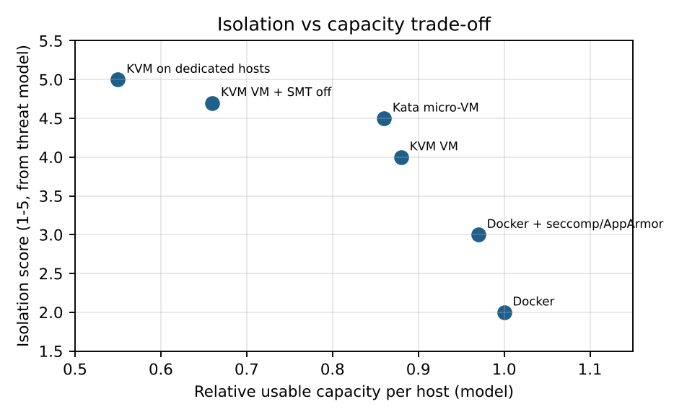
Figure 6.1: Isolation score versus model-predicted usable capacity

6.2 Justification of isolation scores
Configuration | I | Basis for the score
Docker (default) | 2 | One boundary (shared kernel); default seccomp only.
Docker + seccomp/AppArmor/rootless | 3 | Smaller reachable kernel surface and no root on host, but still one kernel.
KVM/QEMU | 4 | Hardware boundary; QEMU sandboxed; side channels remain.
Kata micro-VM | 4.5 | Hardware boundary plus minimal guest kernel and in-guest namespaces.
KVM + SMT off | 4.7 | Removes sibling-thread channels in addition to the hardware boundary.
KVM on dedicated hosts | 5 | No co-tenant on the host at all; remaining risk is the tenant’s own faults.

6.3 Candidate configurations for the original EduCloud workload
Configuration | I | Capacity factor | Feasible for SIS? | Comment
Docker shared | 2 | 1.00 | No (I < 4) | Fails isolation constraint despite best performance.
Docker hardened | 3 | 0.97 | No (I < 4) | Better but still one shared kernel.
KVM shared hosts | 4 | 0.88 | Yes | Meets I ≥ 4; side-channel risk with other departments.
Kata shared hosts | 4.5 | 0.86 | Yes | Strong; higher operational complexity.
KVM + SMT off | 4.7 | 0.66 | Yes (costly) | Capacity falls by about 25%, which is hard to afford at peak.
KVM dedicated hosts | 5 | 0.55 | Yes | Best isolation; lowest multiplexing efficiency.
Capacity factors are rough model-derived multipliers on usable capacity per host and are judgement-based; they illustrate the trade-off rather than precisely quantify it.

6.4 Decision procedure
The decision function is applied per tenant class. Step 1: discard any configuration with I below the tenant’s minimum. Step 2: from the remaining set, discard configurations whose modelled degradation exceeds 10% at the expected R. Step 3: compute the number of hosts needed from the memory and CPU bounds (Task 3) at peak load. Step 4: choose the configuration with the lowest Z, subject to the total of 16 hosts. For SIS, step 1 leaves KVM, Kata and their hardened variants; step 3 favours plain KVM on a dedicated pool (no SMT penalty) because no untrusted tenant shares it. For the external pool, step 1 leaves Kata and KVM + SMT off; Kata wins on start-up time and container workflow.

6.5 Effect of the weight λ
If λ is small the optimiser chooses cheap, dense configurations (Docker) and accepts higher residual risk; as λ grows the optimum moves first to shared KVM and then to dedicated pools. For student records, w_SIS is set high because a breach has legal as well as operational consequences, so the optimum lies in the dedicated KVM region, which is consistent with the data-protection regulation introduced on Day 4.

6.6 Decision procedure as a flow
Figure 6.2 shows the four-step procedure of section 6.4 as a flow. The feedback arrow matters in practice: if no configuration is feasible, either the weight lambda must be revisited with the security owner or more hosts must be bought, and the procedure restarts from step 1.
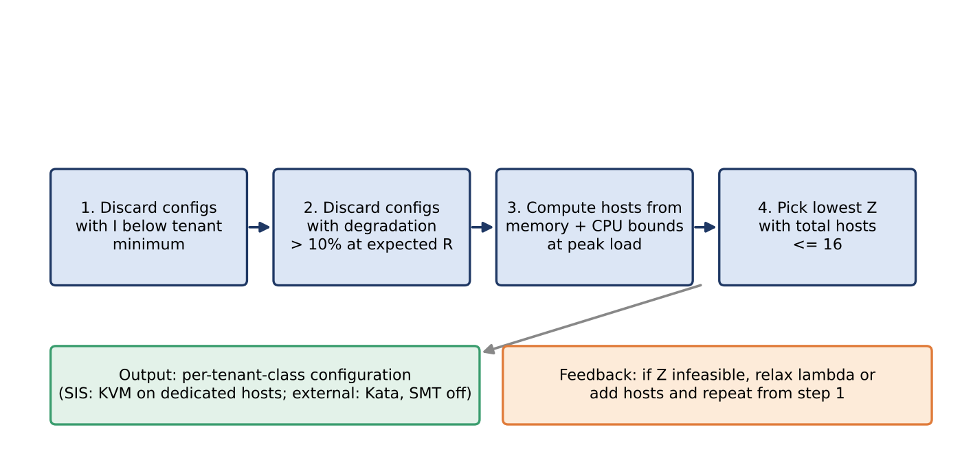
Figure 6.2: Per-tenant decision procedure for choosing an isolation configuration

6.7 Worked example of the cost function for the SIS pool
To show how the objective works, take the capacity factors in section 6.3 and the 10-host dedicated pool required at the registration peak. A dedicated KVM pool with capacity factor 0.55 needs 10 hosts, so the SIS demand corresponds to 10 x 0.55 = 5.5 host-equivalents. The hosts needed by another configuration are 5.5 divided by its capacity factor, rounded up. Assume, for illustration, c_h = 1 per host, w_SIS = 3 and lambda = 3, so each point of missing isolation costs 3 x 3 = 9 host-equivalents. Then Z = hosts + 9 x (5 - I).
Configuration | I | Capacity factor | Hosts needed | Z | Feasible for SIS?
Docker shared | 2 | 1.00 | 6 | 33.0 | No (I < 4)
Docker hardened | 3 | 0.97 | 6 | 24.0 | No (I < 4)
KVM shared | 4 | 0.88 | 7 | 16.0 | Before Day 4 only
Kata shared | 4.5 | 0.86 | 7 | 11.5 | Before Day 4 only
KVM + SMT off | 4.7 | 0.66 | 9 | 11.7 | Yes (costly)
KVM dedicated | 5 | 0.55 | 10 | 10.0 | Yes
Table 6.1: Worked cost-function example (illustrative weights; capacity factors from section 6.3).
The dedicated KVM pool has the lowest Z (10.0), although Kata on shared hosts is close (11.5) and KVM with SMT off is next (11.7). Docker is cheapest in hosts but its isolation penalty makes it by far the most expensive, and it also violates constraint (3). If lambda were halved, Kata on shared hosts would overtake the dedicated pool, which shows that the optimum depends on how heavily student-record risk is weighted. The data-protection regulation in Task 12 removes that ambiguity, because it requires demonstrable separation from external tenants, which shared hosts cannot provide regardless of lambda. The weights here are illustrative and should be stated and defended in your own submission.

Task 7: Evaluate Mitigation Strategies
Mitigation | Threat addressed | Residual risk | Cost (from model) | Acceptable for SIS?
SMT disabled on hosts running mutually untrusted guests | Cross-VM side channels via shared core | Cross-core cache and memory-bus channels remain | If 64 cores are SMT-enabled (128 threads), usable capacity drops about 25% (assumed); fewer instances per host in CPU-bound pools; memory limit unchanged | Not needed for SIS if untrusted tenants are on separate hosts; required for the external pool
Kernel page-table isolation and related CPU mitigations | Kernel memory leakage across privilege boundaries | Other speculative-execution variants | Extra ≈0.1 µs per system call; at 200,000 calls/s per core this is 0.02 s, about 2% of a core | Yes: 2% fits well inside the 10% degradation budget
Dedicated hosts for SIS (host pools) | Escape, side channel, noisy neighbour | Insider/guest compromise inside the pool | Loses statistical multiplexing across pools; SIS pool needs 8–10 hosts for peak (Task 12) | Yes: required by the regulation
Image signing and trusted registry | Image tampering and sprawl | Compromise of the signing key | No run-time overhead; adds start-up delay of seconds for verification | Yes
Micro-segmentation (default-deny virtual network) | Sniffing, spoofing, lateral movement | Misconfigured rules | Extra rule evaluation per packet; reduces η by about 1–2 points (assumed) | Yes
Encrypted live migration (TLS/IPsec) | Memory disclosure in transit | Compromised endpoints | AES-NI encryption uses an estimated 2–3 cores to saturate 25 Gbps; migration time rises roughly 5–10% | Yes

7.2 Combined cost of the SIS mitigation set
The mitigations selected for the SIS pool are KPTI, image signing, micro-segmentation, encrypted migration and dedicated hosts. Their costs combine as follows at R = 4 for KVM: base overhead 6.15% (Task 3) + KPTI 2.0% + micro-segmentation effect on network efficiency (about 1.5 percentage points on I/O-bound work, counted here as 1.5% of CPU) = about 9.65%, which stays just inside the 10% target. Encrypted migration only costs CPU during patch windows, not in steady state. Without KPTI the total would be 7.65%. The margin is thin, so R = 4 is the upper operating limit for SIS and R = 3 is recommended in practice.
Configuration (KVM, R = 4) | Overhead | Margin to 10% | Comment
Baseline | 6.15% | 3.85 pts | No mitigations
+ KPTI | 8.15% | 1.85 pts | Cheap, high-value
+ KPTI + micro-segmentation | 9.65% | 0.35 pts | At the limit; R = 3 advised
+ KPTI + micro-seg. at R = 3 | 8.85% | 1.15 pts | Recommended operating point
Table 7.1: Cumulative cost of mitigations (model estimates).

7.3 Detailed evaluation of selected mitigations

SMT disabled
Applicability: sibling hardware threads share L1 caches and execution units, so a malicious guest on one thread can infer data from a victim on the other. Turning SMT off removes this channel. Residual risk: cross-core channels through shared L3 cache or memory bus remain, so SMT off does not make side channels impossible. Cost: if the 64 cores are SMT-enabled with 128 threads, throughput-oriented capacity falls by about 25% (assumed typical gain from SMT), so the CPU-limited density in Table 3.2 falls proportionally; the memory limit is unchanged. Acceptability: not needed for the SIS pool in the final design because untrusted tenants are on separate hosts; applied on the external pool.

Dedicated hosts for sensitive tenants
Applicability: it removes the co-residency that every cross-tenant attack relies on. Residual risk: attacks from inside the pool (a compromised SIS VM against another SIS VM) and failure of the pool boundary configuration. Cost: lost statistical multiplexing; the Task 12 model needs 10 hosts at peak for 160 VMs, whereas the same VMs mixed with others might fit in fewer hosts on average. Acceptability: yes, because the regulation requires demonstrable isolation.

Image signing and registry control
Applicability: addresses the audit finding that VM images are copied freely between teams. Signatures and a central registry let hosts refuse unknown images. Residual risk: key theft or a vulnerability already present in a signed image. Cost: negligible at run time, plus seconds of start-up for verification. Acceptability: yes; it also lets the university retire outdated guest kernels by revoking old image versions.

Micro-segmentation
Applicability: confines a compromised VM to a small set of permitted flows, which blocks sniffing, spoofing and lateral movement between departments. Residual risk: wrong rules or overly broad groups. Cost: extra rule matching per packet, modelled as 1–2 points of network efficiency. Acceptability: yes.

Encrypted live migration
Applicability: memory pages contain secrets and records; migration traffic must not be readable on the network. Residual risk: an attacker on either endpoint. Cost: AES-NI makes encryption cheap but still consumes an estimated 2–3 cores at line rate and lengthens migration by 5–10%, which affects the convergence condition in Figure 4.2. Acceptability: yes, and migrations are scheduled outside peak load.

7.4 Residual-risk ranking
Residual risk after mitigations | Level | Handling
Zero-day in hypervisor or QEMU | Medium | Rapid patching with live migration; sVirt confinement
Cross-core side channels | Low–Medium | Dedicated pools; no untrusted co-tenants for SIS
Insider or credential misuse | Medium | Least privilege, MFA on management plane, audit logs
Segmentation misconfiguration | Medium | Policy-as-code and periodic verification scans
Unpatched guests | Medium | Golden-image pipeline; scan and expire old images

7.5 Cost of the mitigation set against the degradation budget
Figure 7.1 shows Table 7.1 as a chart. Adding KPTI costs two points and micro-segmentation a further one and a half, taking KVM at R = 4 to 9.65%, which is inside the 10% target but with little margin. Reducing the overcommit to R = 3 recovers about 0.8 points and gives a more comfortable operating point of 8.85%. The chart makes the practical rule easy to see: every mitigation spends part of a fixed budget, so the order in which they are adopted should follow security benefit per point of cost.
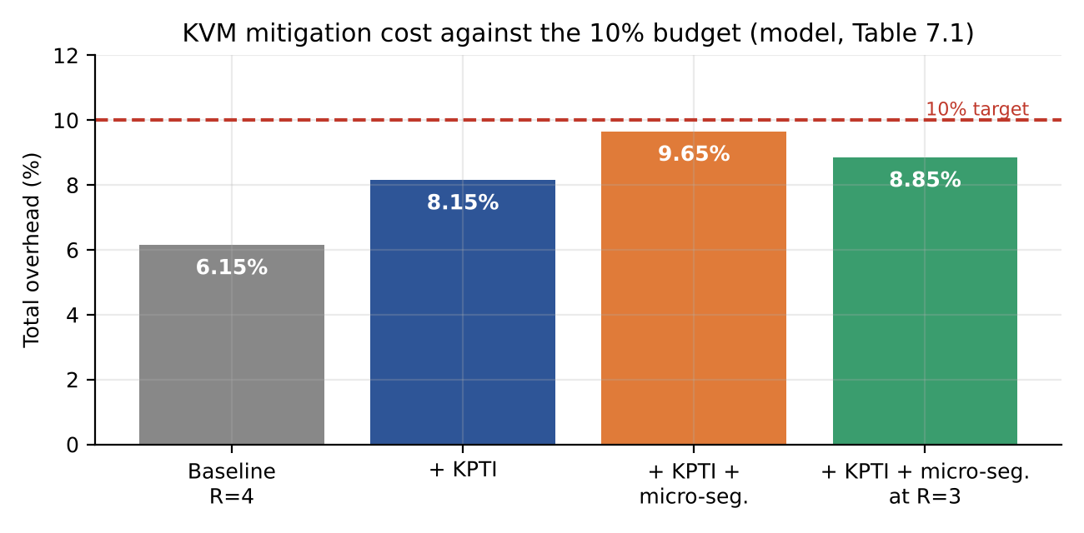
Figure 7.1: Cumulative mitigation cost for KVM at the stated overcommit ratio (model, Table 7.1)

7.6 Ranking the mitigations by benefit and cost
Mitigation | Security benefit | Performance cost | Benefit per unit cost | Priority
Image signing and trusted registry | High (stops tampering and sprawl) | None at run time | Very high | 1
Dedicated hosts for SIS | Very high (removes co-residency) | Loses multiplexing; about 2 extra hosts at peak | High | 1 (regulation)
Kernel page-table isolation | Medium | About 2% of CPU | High | 2
Micro-segmentation | High (lateral movement) | 1 to 2 points of network efficiency | High | 2
Encrypted live migration | High (memory in transit) | 2 to 3 cores during migration; +5 to 10% duration | Medium to high | 2
SMT off | Medium (sibling channel only) | About 25% CPU capacity | Low for SIS, acceptable for external pool | 3 (external pool only)
Table 7.2: Qualitative ranking of the Task 7 mitigations.

7.7 Encrypted migration: effect on migration time
Section 7.3 estimated that encryption lengthens migration by 5 to 10%. Applying that range to the pre-copy formula of Task 4 gives the following times.
VM and dirty rate | Unencrypted | Encrypted (+5%) | Encrypted (+10%)
8 GB, D = 1 GB/s | 3.8 s | 4.0 s | 4.1 s
16 GB, D = 1 GB/s | 7.5 s | 7.9 s | 8.3 s
32 GB, D = 1 GB/s | 15.1 s | 15.8 s | 16.6 s
8 GB, D = 2 GB/s | 7.1 s | 7.5 s | 7.8 s
Table 7.3: Effect of encryption on modelled migration time (model estimate).
The increase is a few tenths of a second for typical SIS VMs when the dirty rate is moderate, which is acceptable for patch windows scheduled outside peak load. The more important effect is on convergence: encryption reduces the effective bandwidth B, and when D is close to B even a 10% reduction can turn a converging migration into a non-converging one. This is one more reason to migrate only quiet VMs and to enable auto-converge.

Task 8: Implement and Test
This procedure is reproducible on a laptop or one workstation. Fill the yellow fields with your actual hardware, and reduce the instance counts proportionally if resources are limited, stating the limitation.
Test platform: [CPU model, cores, RAM, SSD, host OS; nested virtualization yes/no]
Software: Ubuntu 22.04 host, KVM/QEMU with libvirt, Docker Engine, Kata Containers (runtime kata), sysbench, stress-ng, fio, iperf3.

8.1 Environment setup
sudo apt update && sudo apt install -y qemu-kvm libvirt-daemon-system virtinst \
docker.io sysbench stress-ng fio iperf3 sysstat
egrep -c '(vmx|svm)' /proc/cpuinfo # >0 means hardware virtualization is present
lsmod | grep kvm
# Install Kata per its official instructions, then verify:
docker run --rm --runtime kata-runtime alpine uname -r

8.2 Identical resource allocation
Every instance is given 2 vCPUs/CPU limit and 2 GB RAM (scaled down from the 4 vCPU/8 GB model; the model is re-evaluated with these values in Task 10). Example launch commands:
# A: KVM guest (repeat n times with different names)
virt-install --name vm$i --vcpus 2 --memory 2048 --disk size=10 \
--cdrom ubuntu.iso --os-variant ubuntu22.04 --noautoconsole
# B: Docker container
docker run -d --name c$i --cpus 2 --memory 2g ubuntu:22.04 sleep infinity
# C: Kata container
docker run -d --runtime kata-runtime --name k$i --cpus 2 --memory 2g ubuntu:22.04 sleep infinity

8.3 Workloads (run 5 repetitions per setting; instances = 1, 2, 4, 8, 16)
# CPU-bound
sysbench cpu --threads=2 --time=30 run
# Memory-intensive
sysbench memory --memory-block-size=1M --memory-total-size=10G run
# Disk I/O
fio --name=rr --rw=randrw --bs=4k --size=1G --runtime=30 --time_based \
--ioengine=libaio --iodepth=16 --output-format=json
# Network (server on host, client in instance)
iperf3 -s & # on host
iperf3 -c <host-ip> -t 30 -P 2

8.4 Noisy-neighbour experiment
# Run a victim benchmark in instance 1 while instance 2 runs a hog:
stress-ng --cpu 2 --vm 1 --vm-bytes 80% --io 2 --timeout 60s
# Record victim throughput and p95 latency with and without the hog.

8.5 Metrics collection
mpstat -P ALL 1 60 > mpstat.log # includes %steal inside guests
pidstat -w 1 60 > ctxsw.log # context switches
perf stat -e kvm:kvm_exit -a sleep 30 # VM exits (KVM/Kata, if permitted)
time docker run --rm alpine true # start-up time (use virsh start for KVM)
docker stats --no-stream # memory footprint of containers

8.6 Security validation
uname -r # kernel seen from each environment
docker run --rm alpine uname -r # same kernel as host => shared kernel (B)
docker run --rm --runtime kata-runtime alpine uname -r # different guest kernel (C)
lsns # namespaces on host
cat /sys/devices/system/cpu/smt/active # 1 = SMT on, 0 = off
grep . /sys/devices/system/cpu/vulnerabilities/* # which mitigations are active

Screenshots required: [Insert screenshot of the KVM, Docker and Kata instances running] [Insert screenshot of kernel version comparison] [Insert screenshot of one benchmark output]
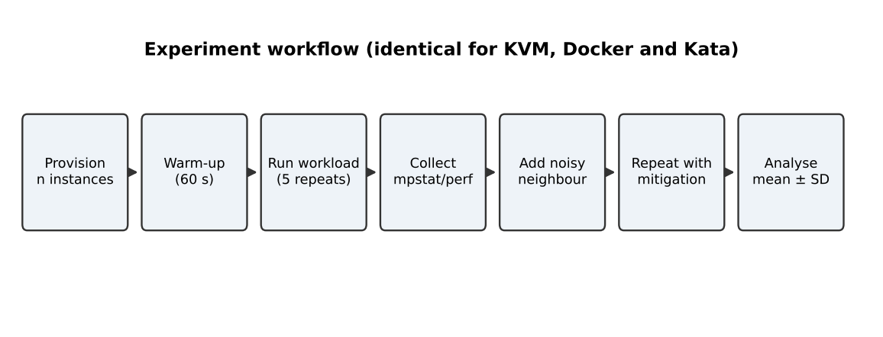
Figure 8.1: Experimental workflow used for all three approaches

8.7 Test matrix
Factor | Levels | Count | Note
Approach | Bare metal, KVM, Docker, Kata | 4 | Bare metal is the baseline for degradation
Instances | 1, 2, 4, 8, 16 | 5 | Reduce if hardware-limited and state it
Workload | CPU, memory, disk, network | 4 | sysbench, sysbench memory, fio, iperf3
Repetitions | 5 per setting | 5 | Report mean and standard deviation
Interference | With and without noisy neighbour | 2 | Victim is instance 1
Mitigation | With and without one mitigation | 2 | For example SMT off or KPTI
Number of runs for the main grid: 4 × 5 × 4 × 5 = 400 runs (about 30 s each, so under 4 hours of benchmark time plus set-up). The interference and mitigation experiments add roughly 100 further runs. If time is short, reduce the instance levels to 1, 2, 4, 8 and state the change.

8.8 Automation script
The script below runs the CPU, memory and disk workloads for one approach and one instance count, repeating each five times and saving raw output. It assumes instances are reachable by SSH (VMs) or docker exec (containers); adjust names to your set-up.
#!/usr/bin/env bash
# usage: ./run_tests.sh <approach> <n_instances>
APPROACH=$1; N=$2; OUT=results/$APPROACH/n$N; mkdir -p $OUT
run_in() { # run a command in instance $1
case $APPROACH in
kvm) ssh ubuntu@vm$1 "$2" ;;
docker) docker exec c$1 bash -c "$2" ;;
kata) docker exec k$1 bash -c "$2" ;;
esac
}
for rep in 1 2 3 4 5; do
for i in $(seq 1 $N); do
run_in $i 'sysbench cpu --threads=2 --time=30 run' > $OUT/cpu_${i}_$rep.txt &
done; wait
for i in $(seq 1 $N); do
run_in $i 'sysbench memory --memory-total-size=10G run' > $OUT/mem_${i}_$rep.txt &
done; wait
for i in $(seq 1 $N); do
run_in $i 'fio --name=t --rw=randrw --bs=4k --size=1G --runtime=30 --time_based --output-format=json' \
> $OUT/fio_${i}_$rep.json &
done; wait
done

8.9 Example configuration fragments
# KVM: pin vCPUs and use hugepages (libvirt XML fragment)
<vcpu placement='static' cpuset='0-3'>2</vcpu>
<memoryBacking><hugepages/></memoryBacking>
<cpu mode='host-passthrough'/>

# Docker: limits for an instance
docker run -d --cpus 2 --memory 2g --pids-limit 512 \
--blkio-weight 500 --security-opt no-new-privileges ubuntu:22.04 sleep infinity

# Kata: select runtime in /etc/docker/daemon.json
{ "runtimes": { "kata-runtime": { "path": "/usr/bin/kata-runtime" } } }

8.10 Limitations and troubleshooting
Limitations of your test bench: [Describe your hardware limits, for example number of cores, RAM, whether nested virtualization was used, and how you scaled instance counts]
Problem | Likely fix
kvm module not loaded / no /dev/kvm | Enable virtualization in BIOS; with nested virtualization enable the nested option in the outer hypervisor.
Kata runtime fails to start | Check hardware virtualization is exposed to the host and the runtime path in daemon.json.
High run-to-run variance | Disable CPU frequency scaling (set performance governor), close other applications, add warm-up, increase repetitions.
iperf3 results unrealistically high | Client and server on the same host use loopback; use a separate server or document the limitation.
fio results look too fast | The page cache is being used; add direct=1 to bypass it.

8.11 Test-bench layout
Figure 8.2 shows how the pieces of the test bench connect. All three approaches run on the same host, share the same NVMe device and software switch, and are measured with the same tools, so any difference in results comes from the virtualization layer and not from the setup. Run the iperf3 server on a second machine if possible; if the server runs on the same host, traffic goes through loopback and the throughput figure is not meaningful for the network model.
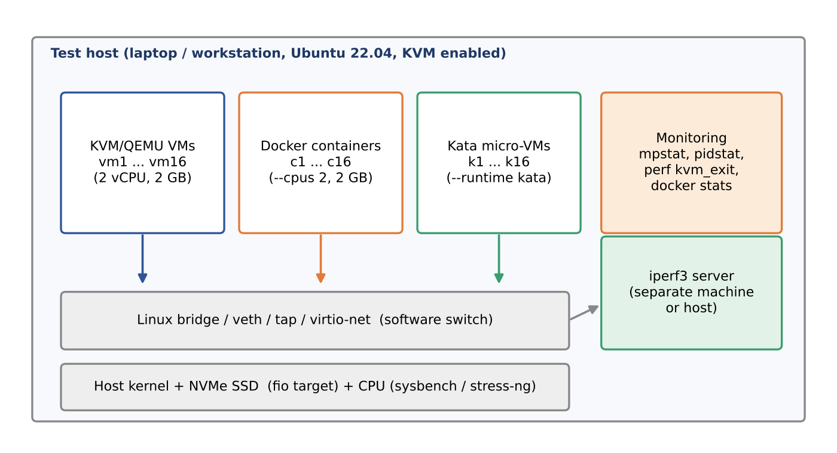
Figure 8.2: Test-bench layout (diagram of the setup described in this task)

8.12 Preparing the host for repeatable results
Variance between runs is the main threat to a comparison on a laptop. The following commands remove the most common sources of noise. Record the output of each command in your lab notes.
# fixed CPU frequency (avoid turbo and power-saving changes)
sudo apt install -y linux-tools-common linux-tools-$(uname -r)
sudo cpupower frequency-set -g performance

# empty the page cache before each fio run
sync; echo 3 | sudo tee /proc/sys/vm/drop_caches

# SMT control for the mitigation experiment (Table 9.3)
cat /sys/devices/system/cpu/smt/control # on / off
echo off | sudo tee /sys/devices/system/cpu/smt/control
echo on | sudo tee /sys/devices/system/cpu/smt/control

# record the host state once per session
lscpu > host_lscpu.txt; free -h > host_mem.txt; uname -a > host_kernel.txt

If your Kata installation uses the newer containerd shim, replace --runtime kata-runtime in the earlier commands by --runtime io.containerd.kata.v2 and check your version's documentation; the runtime name differs between releases.

8.13 Pre-flight checklist and evidence capture
Check before measuring | How to verify | Screenshot or log to keep
Hardware virtualization enabled | egrep -c "(vmx|svm)" /proc/cpuinfo; ls /dev/kvm | Terminal output showing a non-zero count
Same resources for every instance | virsh dominfo; docker inspect (CPU and memory limits) | One screenshot per approach
CPU governor and SMT state recorded | cpupower frequency-info; cat .../smt/active | Output saved with each result set
Kernel isolation property | uname -r in host, Docker and Kata | Kernel version comparison (required screenshot)
Active CPU vulnerability mitigations | grep . /sys/devices/system/cpu/vulnerabilities/* | Output before and after the mitigation test
Idle baseline noise | mpstat 1 30 with no workload | Log showing idle CPU and steal time
Benchmark output | sysbench, fio JSON and iperf3 result for one run | One screenshot of each tool
Table 8.1: Pre-flight checks and the evidence to keep for the Implementation Evidence Chain.

8.14 Suggested schedule
The assignment gives one week. Figure 8.3 proposes a plan that keeps the longest benchmark runs overnight and leaves a full day for graphs and error analysis. Adjust it to your hardware, and reduce the instance counts rather than the repetitions if time runs short.
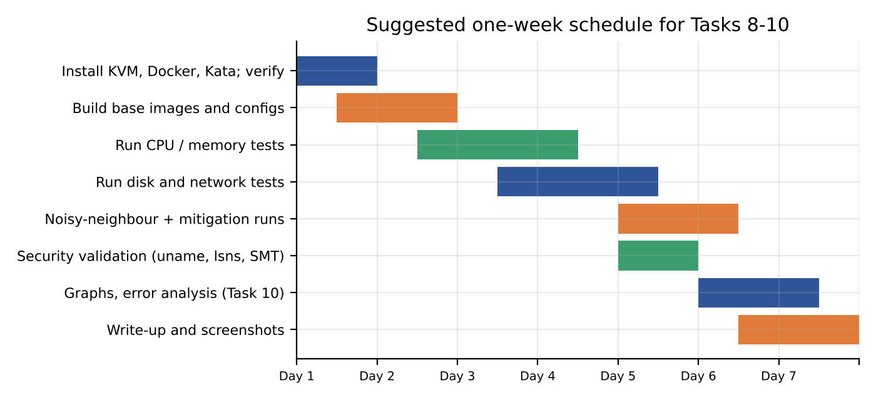
Figure 8.3: Suggested one-week schedule for Tasks 8 to 10 (planning aid)

Task 9: Record Experimental Performance
Record every repetition in a spreadsheet and compute the mean and sample standard deviation. A quick way to do that:
python3 - <<'EOF'
import statistics as s
runs = [/* paste your 5 measured values here */]
print(round(s.mean(runs),2), '+/-', round(s.stdev(runs),2))
EOF

Table 9.1: Results at 4 instances (mean ± SD of 5 runs) – fill from your measurements
Approach | CPU events/s | Disk IOPS | iperf3 Gbps | p95 latency (ms) | Degradation vs bare metal (%)
Bare metal (baseline) | [ ] | [ ] | [ ] | [ ] | [ ]
A. KVM/QEMU | [ ] | [ ] | [ ] | [ ] | [ ]
B. Docker | [ ] | [ ] | [ ] | [ ] | [ ]
C. Kata | [ ] | [ ] | [ ] | [ ] | [ ]

Table 9.2: Start-up time, footprint, CPU steal and context switches – fill from your measurements
Approach | Start-up time (s) | Memory footprint per instance (MB) | CPU steal (%) | Context switches/s
A. KVM/QEMU | [ ] | [ ] | [ ] | [ ]
B. Docker | [ ] | [ ] | [ ] | [ ]
C. Kata | [ ] | [ ] | [ ] | [ ]

Table 9.3: Effect of one mitigation (for example SMT off, or KPTI on)
Approach | Throughput without | Throughput with | Change (%)
A. KVM/QEMU | [ ] | [ ] | [ ]
C. Kata | [ ] | [ ] | [ ]

Graph 1: [Insert graph: throughput versus number of instances (1, 2, 4, 8, 16), one line per approach, error bars = SD]
Graph 2: [Insert graph: p95 latency of victim instance with and without noisy neighbour]

9.4 Scaling table (fill from your measurements)
Throughput per instance (mean ± SD) | n = 1 | n = 2 | n = 4 | n = 8 | n = 16
Bare metal (n = 1 only) | [ ] | — | — | — | —
A. KVM/QEMU | [ ] | [ ] | [ ] | [ ] | [ ]
B. Docker | [ ] | [ ] | [ ] | [ ] | [ ]
C. Kata | [ ] | [ ] | [ ] | [ ] | [ ]

9.5 Interference results (fill from your measurements)
Approach | Victim throughput alone | Victim with noisy neighbour | p95 latency alone | p95 latency with noisy neighbour
A. KVM/QEMU | [ ] | [ ] | [ ] | [ ]
B. Docker | [ ] | [ ] | [ ] | [ ]
C. Kata | [ ] | [ ] | [ ] | [ ]

9.6 Raw-data log (one line per run)
Run | Approach | n | Workload | Result | Steal % | Notes
1 | [ ] | [ ] | [ ] | [ ] | [ ] | [ ]
2 | [ ] | [ ] | [ ] | [ ] | [ ] | [ ]
3 | [ ] | [ ] | [ ] | [ ] | [ ] | [ ]

9.7 Analysis and plotting script
Save your measured values in results.csv with the columns approach, n, workload, value and then run:
import pandas as pd, matplotlib.pyplot as plt
df = pd.read_csv('results.csv')
g = df[df.workload=='cpu'].groupby(['approach','n'])['value'].agg(['mean','std']).reset_index()
for a, d in g.groupby('approach'):
plt.errorbar(d.n, d['mean'], yerr=d['std'], marker='o', capsize=3, label=a)
plt.xscale('log', base=2); plt.xlabel('Instances'); plt.ylabel('CPU events/s per instance')
plt.legend(); plt.grid(alpha=.3); plt.savefig('throughput_vs_instances.png', dpi=200)
# baseline degradation: 100*(baseline-mean)/baseline

9.8 Reporting guidance
- Report each result as mean ± sample standard deviation of at least five runs; mention if any run was discarded and why.
- Use the same axis scales across approaches so that curves can be compared directly.
- Label graphs with units, instance counts and whether the noisy neighbour or a mitigation was active.
- Keep raw logs (mpstat, perf, fio JSON) as evidence and include one or two screenshots of them.

9.9 Data-quality checklist
Before any number goes into Tables 9.1 to 9.5 or into the graphs, check it against the following list. A result that fails a check should be repeated or explained, not silently kept.
Check | Why it matters | Pass criterion
At least five repetitions per setting | Gives a usable mean and standard deviation | n >= 5 for every cell
Warm-up run discarded | First run includes cold caches and page-cache fill | Warm-up not in the statistics
Coefficient of variation (SD / mean) | Shows whether noise hides the effect being measured | Below about 5%; if higher, repeat or state it
Same allocation in all approaches | Otherwise differences are not due to the architecture | 2 vCPU and 2 GB everywhere
Disk test bypasses page cache | Otherwise fio measures RAM | direct=1 in the fio command
Network test crosses a real link | Loopback is not a network measurement | Server on another machine, or limitation stated
Baseline measured in the same session | Thermal state and background load drift over days | Bare-metal run on the same day
Table 9.7: Checks to apply to every measurement.

9.10 Script for Graph 2 and the degradation column
Graph 1 is produced by the script in section 9.7. The following extension produces Graph 2 (victim p95 latency with and without the noisy neighbour) and the degradation percentage used in Table 9.1. Save your values in latency.csv with the columns approach, condition (alone or noisy), run and p95_ms.
import pandas as pd, matplotlib.pyplot as plt
df = pd.read_csv("latency.csv")
g = df.groupby(["approach","condition"])["p95_ms"].agg(["mean","std"]).reset_index()

apps = list(g.approach.unique()); w = 0.35
for k, cond in enumerate(["alone","noisy"]):
d = g[g.condition == cond].set_index("approach").loc[apps]
plt.bar([i + k*w for i in range(len(apps))], d["mean"], w, yerr=d["std"], capsize=3, label=cond)
plt.xticks([i + w/2 for i in range(len(apps))], apps)
plt.ylabel("Victim p95 latency (ms)"); plt.legend(); plt.grid(alpha=.3)
plt.savefig("latency_interference.png", dpi=200)

# degradation versus bare metal (per cell of Table 9.1)
# degradation_% = 100 * (baseline - measured) / baseline (throughput metrics)
# degradation_% = 100 * (measured - baseline) / baseline (latency metrics)

9.11 Reading the results before you write them up
- Look at the spread first. If the standard deviation is larger than the difference between two approaches, say that the difference is not resolved by your data.
- Compare shape, not only level. Table 9.4 should show how throughput per instance falls as n grows. A curve that falls like 1/n for network or disk means the shared device is the limit, as the Task 3 model predicts.
- Separate noise from effect. Report the noisy-neighbour effect as a ratio (latency with divided by latency alone) so that it can be compared across approaches with different absolute speeds.

Task 10: Compare Theory with Experiment
Re-run the Task 3 model with the test-bench parameters (2 vCPU, 2 GB guests, your core count) and compute the prediction error for every approach:
error (%) = 100 × (measured − predicted) / predicted
Metric / approach | Predicted | Measured | Error (%) | Plausible cause
CPU degradation at R = 2 – KVM | ≈4.5% | [ ] | [ ] | [ ]
CPU degradation at R = 2 – Docker | ≈0.5% | [ ] | [ ] | [ ]
CPU degradation at R = 2 – Kata | ≈3.3% | [ ] | [ ] | [ ]
Net share, n = 4 – KVM (Gbps) | 5.75 | [ ] | [ ] | [ ]

Guidance for the discussion (write your own conclusions after you have data):
- Trend check: does measured degradation rise with instance count in the order the model predicts (Docker < Kata < KVM for CPU; the reverse ordering for isolation)? Say clearly where it does and does not.
- Scaling: state which approach lost the least throughput going from 1 to 16 instances, using your Graph 1.
- Error causes: typical reasons for deviations are nested virtualization (inflates exit cost far above 1.5 µs), laptop thermal throttling and turbo-boost changes, SMT siblings, the hypervisor scheduler batching exits, page-cache effects in fio, and I/O paths the model leaves out (virtio-fs, overlayfs, host softirq).
- Security effect: if your measurements show a mitigation costs more than modelled (for example SMT off), say whether that changes the Task 5 and Task 7 recommendations.

10.5 Error metrics
For a set of k paired observations, the mean absolute percentage error is MAPE = (100/k) Σ |measured_i − predicted_i| / predicted_i. Values below about 15% indicate that the model captures the main behaviour; values above 30% suggest a missing term. The coefficient of determination R² between predicted and measured degradation across instance counts indicates whether trends agree even if absolute levels differ. Also compute the coefficient of variation (SD/mean) for each measurement; if the CV is larger than the effect you are trying to detect (for example a 2% mitigation cost), the experiment cannot support that conclusion and needs more repetitions.
Comparison | MAPE | R² of trend | Interpretation (your words)
CPU degradation, A | [ ] | [ ] | [ ]
CPU degradation, B | [ ] | [ ] | [ ]
CPU degradation, C | [ ] | [ ] | [ ]
Network share, A/B/C | [ ] | [ ] | [ ]

10.6 Threats to validity
- Internal: background processes, thermal throttling and turbo frequency changes between runs can bias results; use the same warm-up and governor settings for every approach.
- Construct: sysbench and fio are synthetic; real SIS workloads mix CPU, network and database operations, so degradation could differ.
- External: a laptop with fewer cores and nested virtualization does not reproduce the 64-core server; trends transfer better than absolute numbers.
- Statistical: five repetitions give limited power; large standard deviations should be stated and conclusions softened accordingly.

10.7 Expected qualitative outcomes to check against your data
The model predicts the following qualitative ordering, which you should confirm or reject with your measurements: (1) CPU-bound overhead: Docker lowest, then Kata, then KVM; (2) start-up time: Docker fastest, Kata next, KVM slowest; (3) memory footprint per instance: Docker smallest, Kata middle, KVM largest; (4) noisy-neighbour impact on a victim: Docker most affected, VM-based approaches less; (5) security checks: Docker shows the host’s kernel version inside the container, while KVM and Kata show an independent guest kernel. If your results disagree with any of these, discuss why rather than adjusting the numbers; a documented disagreement with a good explanation earns more credit than forced agreement.

10.8 Model prediction to overlay with your data
Figure 10.1 shows the model curves for CPU overhead against overcommit ratio, drawn from the Task 3 equation. Plot your measured degradation at the same R values on top of it (for example with matplotlib's errorbar function using the same axes). Points on or near a line support the model for that approach; points far above it point to a missing term, usually nested virtualization (which makes each exit much more expensive than 1.5 µs), scheduler effects or thermal throttling. Remember that the laptop test bench has fewer cores, so compute the curves again with your own core count and 2 vCPU guests before comparing.
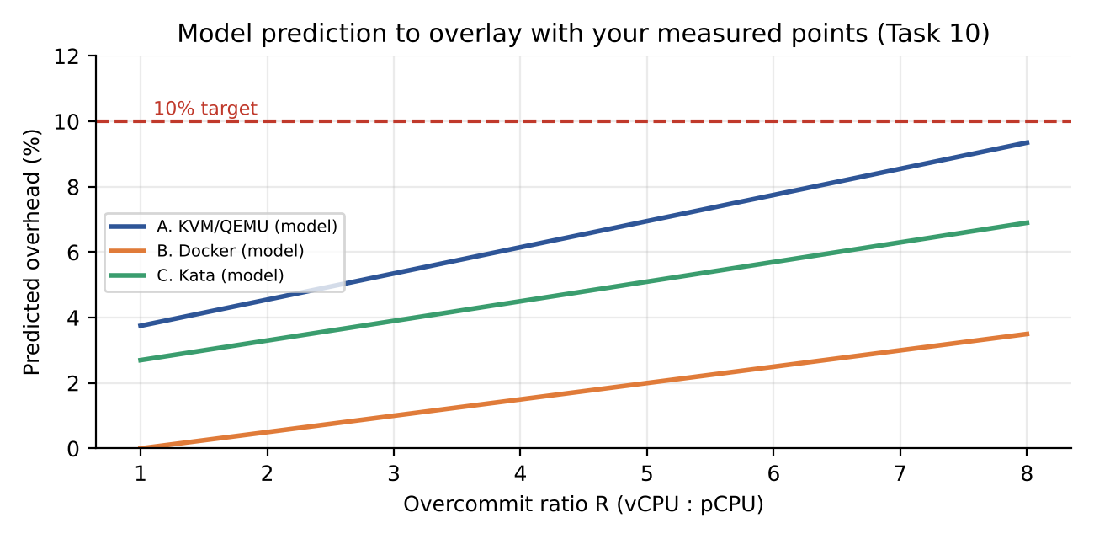
Figure 10.1: Model-predicted CPU overhead against overcommit ratio (prediction only; overlay your measured points)

10.9 Template for the error calculation
For each cell in the comparison table, work through the following steps and show them in your report. The symbols are placeholders for your own numbers.
- Step 1: prediction. Recompute C(R) = (1/R)(1 - f t_exit - gamma(R - 1)) with the test-bench R, then predicted degradation = 1 - C(R) / (1/R) = f t_exit + gamma(R - 1).
- Step 2: measurement. Compute mean and sample standard deviation of the five runs, then degradation_measured = 100 x (baseline - mean) / baseline.
- Step 3: error. error % = 100 x (measured - predicted) / predicted. Also give the absolute difference in percentage points, because relative error is unstable when the predicted value is close to zero (for example Docker at R = 2).
- Step 4: uncertainty. Check whether predicted lies within one standard deviation of the measured mean. If it does, the model is consistent with the data at this sample size.
- Step 5: cause. Choose the most likely cause from the table below and say what you would measure to confirm it.

10.10 Interpretation guide
If you observe | Most likely meaning | Follow-up action
KVM overhead far above prediction | Nested virtualization or a higher exit rate than assumed | Measure kvm_exit counts with perf; replace f in Table 3.1
Docker overhead above prediction at high n | Conntrack or softirq saturation in the shared kernel | Check softirq in /proc/softirqs and conntrack usage
Kata slower than KVM on disk tests | virtio-fs round trips for small files | Repeat with a block device or larger I/O sizes
Throughput per instance does not fall as 1/n | Device not saturated or cache effects | Increase load or use direct=1 and a larger file
Large run-to-run variance | Thermal throttling, turbo changes, background load | Fix governor, close applications, add repetitions
Mitigation costs more than modelled | CPU model or workload with many system calls | Update the Task 7 cost and re-check the 10% budget
Table 10.1: Guide for interpreting deviations between model and measurement.

Task 11: Recommend and Defend the Final Architecture
Recommendation: a hybrid. Run SIS, LMS and the examination portal as KVM/QEMU virtual machines on dedicated hosts, with signed images, encrypted live migration and a micro-segmented network. Run mutually trusted departmental and stateless services in hardened Docker containers. Use Kata micro-VMs for anything from less-trusted tenants.
- Why not all Docker: the shared kernel gives an isolation score of only 2, below the SIS requirement (Task 6), even though the model shows the best CPU efficiency (R* = 21).
- Why not Kata everywhere: it is strong, but it adds an extra layer to operate and I/O efficiency is lowest in the model (η = 0.85). For trusted, long-lived SIS services, plain KVM with its mature tooling and live migration is simpler.
- Performance (modelled): at 4:1 overcommit KVM loses about 6.2% to virtualization, inside the 10% target, and fair-share network throughput at 8 co-tenants is 2.9 Gbps per VM. Observed values must be added from Table 9.1: [insert measured degradation for KVM]
- Security posture: VM-level isolation plus the Task 7 controls. Residual risks: hypervisor/QEMU zero-days, cross-core side channels and insider misuse inside the pool.
- Operations: each VM guest kernel must be patched; use a golden-image pipeline and automatic compliance scans. Live migration allows host patching without downtime. Monitoring should track steal time, exit rate, memory pressure and p95 latency.
- Growth to several thousand instances: memory is the binding constraint at about 59–67 8-GB VMs per host, so 5,000 instances would need roughly 5,000/59 ≈ 85 hosts. Right-sizing guests, KSM and moving stateless tiers to containers reduce that. The pool-based design scales by adding hosts to a pool rather than redesigning.
- Limitations: model constants are assumptions; results from a laptop test bench may not transfer to the production hardware.

11.1 Weighted decision matrix
Scores run from 1 (poor) to 5 (excellent) and are judgement-based, informed by the model results and the threat model. Weights reflect SIS/LMS priorities.
Criterion (weight) | Weight | A. KVM | B. Docker | C. Kata | Source of score
Performance | 20% | 3 | 5 | 3 | Tasks 3–4
Isolation | 35% | 4 | 2 | 4.5 | Tasks 5–6
Density/cost | 10% | 3 | 5 | 3 | Task 3 density
Operability | 15% | 4 | 4 | 3 | Patching, tooling
Migration / HA | 20% | 5 | 1 | 2 | Live migration
Weighted total | 100% | 3.90 | 3.00 | 3.33 | —
Table 11.1: Weighted scoring for the SIS/LMS workload.
KVM scores highest for SIS and LMS, mainly because of isolation and live migration. Docker wins on performance and density but fails the isolation requirement, and Kata is strong on isolation but weaker on operability and migration. The ranking would only change if isolation were weighted far below the other criteria, which is unrealistic for student records.

11.2 Growth from 400 to several thousand instances
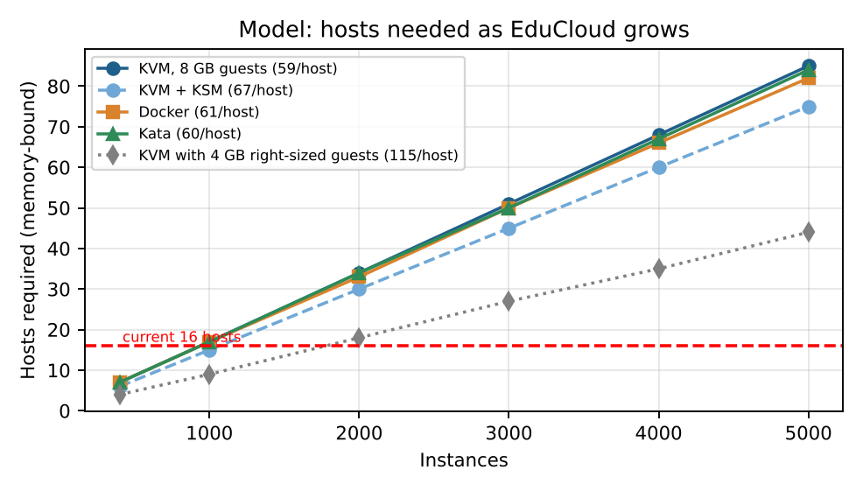
Figure 11.1: Hosts required as instance count grows (memory-bound model)
At 8 GB per instance, 400 instances need about 7 hosts, 2,000 need 34 and 5,000 need 85 hosts. The slope is almost identical for all three approaches because memory dominates. Right-sizing guests to 4 GB halves the requirement (5,000 instances need about 44 hosts at 115 per host), and KSM gives about a 12% reduction for KVM. Growth therefore needs a capacity process that tracks memory demand per tenant, not only CPU.

11.3 Operational cost comparison
Operational area | A. KVM | B. Docker | C. Kata
Patching | Host plus every guest kernel; live migration avoids downtime | Host kernel once; rebuild and redeploy images | Host plus guest kernel (shared minimal image); restart pods
Image management | Golden VM images; sprawl risk | Layered registry; fast, but tag drift risk | Same as Docker, plus guest kernel/rootfs versioning
Migration | Live, with encryption | Reschedule (restart) | Reschedule (restart)
Monitoring | Steal time, exits, memory pressure, p95 latency | cgroup metrics, conntrack, softirq | VMM, agent and virtiofsd health plus guest metrics
Skills required | Mature, widely known | Widely known | Newer, fewer experienced operators

11.4 Risk register for the recommended design
Risk | Likelihood | Impact | Mitigation
Memory exhaustion at peak | Medium | High | Memory-based admission control, ballooning, alerts at 85% usage
Hypervisor vulnerability | Low–Medium | High | Patch via live migration; dedicated SIS pool
Image sprawl / old kernels | High | Medium | Signed golden images, expiry policy, scanning
Migration failure at peak | Medium | Medium | Freeze migrations during registration week; auto-converge
Operator error in segmentation | Medium | High | Policy-as-code, peer review, automated verification

11.5 Contribution of each criterion and sensitivity to the weights
Figure 11.2 splits each weighted total of Table 11.1 into the contribution of each criterion. KVM's lead comes from isolation and migration, Docker's from performance and density, and Kata's strength is almost entirely isolation. The sensitivity table answers a likely viva question: what happens if the isolation weight is reduced. The other weights are scaled proportionally so that the total stays at 100%.
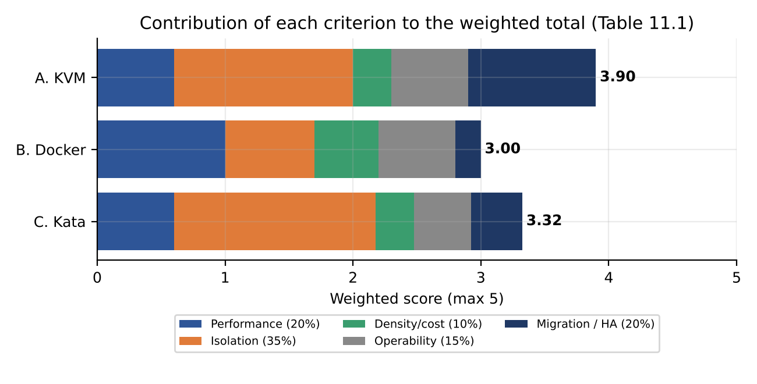
Figure 11.2: Contribution of each criterion to the weighted score of each approach (Table 11.1)
Isolation weight | A. KVM | B. Docker | C. Kata | Highest score
35% | 3.90 | 3.00 | 3.33 | A. KVM
20% | 3.88 | 3.23 | 3.05 | A. KVM
10% | 3.86 | 3.38 | 2.87 | A. KVM
5% | 3.85 | 3.46 | 2.78 | A. KVM
0% | 3.85 | 3.54 | 2.69 | A. KVM
Table 11.2: Weighted totals when the isolation weight is reduced and the other weights are rescaled (judgement-based scores).
KVM stays first at every isolation weight in the table, even when the weight is set to zero. Live migration and operability keep it ahead of Docker, although Docker closes the gap as the isolation weight falls (to within about 0.3 points). The recommendation is therefore robust to the weights. It still depends on the scores themselves, which are judgements informed by Tasks 3 to 5 and should be re-scored with your measured results. Note also that a weighted sum hides hard constraints: Docker at I = 2 is excluded for SIS by the isolation constraint in Task 6 whatever its score.

11.6 Which workload goes where
Figure 11.3 turns the hybrid recommendation into a placement rule that operators can apply to a new workload. The questions are asked in order of risk, so a workload that holds student records never lands in a weaker pool by accident.
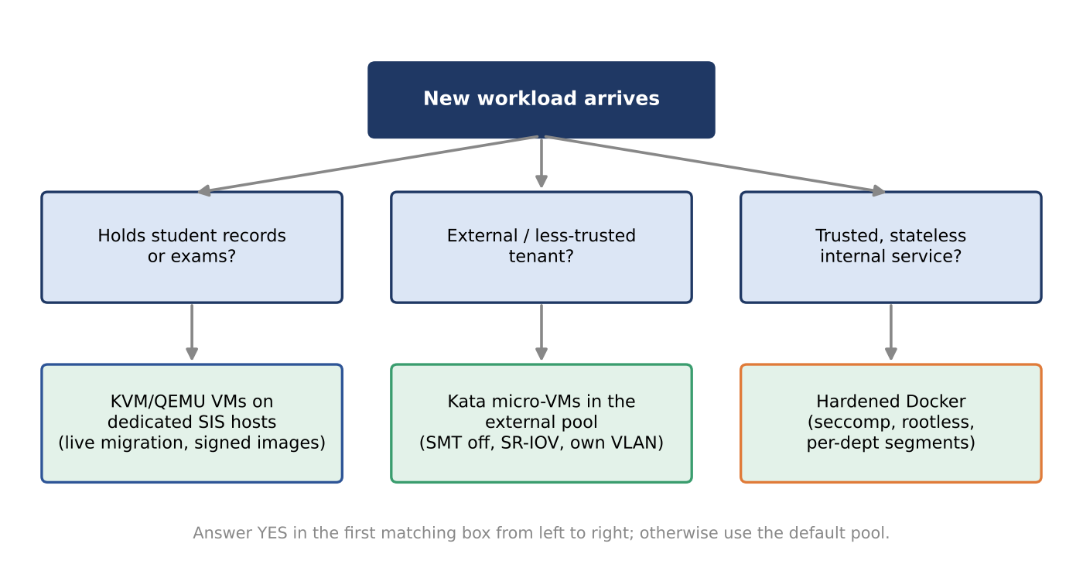
Figure 11.3: Placement rule for new workloads in the recommended hybrid design

11.7 Phased rollout
Phase | Timing (suggested) | Actions | Exit criterion
0. Baseline | Weeks 1 to 2 | Enable monitoring of steal time, exit rate, memory pressure, p95 latency; inventory all images and guest kernels | Dashboards live; image inventory complete
1. Hygiene | Weeks 3 to 6 | Golden-image pipeline, image signing, patch outdated guests, default-deny network policy | No unsigned image running; no guest older than policy
2. SIS pool | Weeks 7 to 12 | Move SIS, LMS and exam VMs to dedicated KVM hosts; enable encrypted migration; load test at 3x | Load test meets the 70% utilisation target
3. Other pools | Weeks 13 to 20 | Create internal and external pools; deploy Kata and SR-IOV for external workloads | Cross-pool access blocked and verified
4. Operate and grow | Continuous | Capacity review each semester using the memory-bound model; periodic audits of pool boundaries | Audit evidence package produced on request
Table 11.3: Suggested rollout plan for the recommended architecture.

11.8 Service-level indicators to monitor
Indicator | Target (proposed) | Source of the target
Core utilisation in the SIS pool at peak | At most 70% | Task 6 constraint (5); Figure 3.8
Memory use per host | Alert at 85%; hard limit at N_max | Task 3 memory model; Task 11 risk register
CPU steal time of SIS guests | Below about 5% sustained | Operational guideline; compare with Table 3.3
p95 login latency | Within the agreed service target; track the trend weekly | Task 4 condition analysis
Guest kernel age | No guest older than the patch policy | Audit finding on outdated kernels
Migration events during freeze windows | Zero | Task 12 migration policy
Table 11.4: Indicators and proposed targets for the recommended architecture.

Day-4 Design Challenge – Task 12

A. Impact Analysis
The new requirements invalidate several earlier assumptions. First, tenants are no longer all trusted: external collaborators run code the university does not control, so the threat model moves from accidental interference to deliberate attack, including escape and side-channel attempts. Second, the workload mix changes from short, latency-sensitive transactions to long, I/O- and network-heavy batch jobs. Spark and Hadoop shuffle phases can saturate the NIC and NVMe queues for hours, so the I/O share T(n) = ηL/n applies for much longer and p95 latency for SIS rises. Third, a 3× registration peak combined with batch jobs on the same hosts leaves no headroom: if the SIS busy fraction rises from 20% to 60% while batch jobs hold the cores at 100%, steal time grows quickly. Fourth, live-migration patching moves memory contents across the network, which is now an exfiltration risk and competes with shuffle traffic. Finally, the data-protection regulation requires demonstrable isolation, which a shared-host design cannot show.

B. Evaluation of the Original Design
Using the Task 3 model with the new workload: assume 160 SIS/LMS/exam VMs at 4 vCPU (640 vCPU). On 8 hosts (512 pCPU) the overcommit is R = 1.25, overhead 4.0%, and the peak 60% busy load of 384 busy vCPUs gives a utilisation of 384 / (512 × 0.96) = 78%, above the 70% target. On 10 hosts (640 pCPU), R = 1.0, overhead 3.75% and utilisation is 62%, which meets the target. The original design placed batch jobs on the same hosts, so it fails on both counts: performance (batch jobs cause steal and I/O contention) and isolation (shared kernel or shared host with external tenants gives I below the required 4 for those workloads). A different architecture does better overall: Kata micro-VMs for external jobs give VM-grade isolation with container workflow, at a modest efficiency cost (η = 0.85 vs 0.92).

C. Adaptation or Redesign
Decision: modify (keep KVM for SIS, add tenant separation). The revised architecture uses host pools:
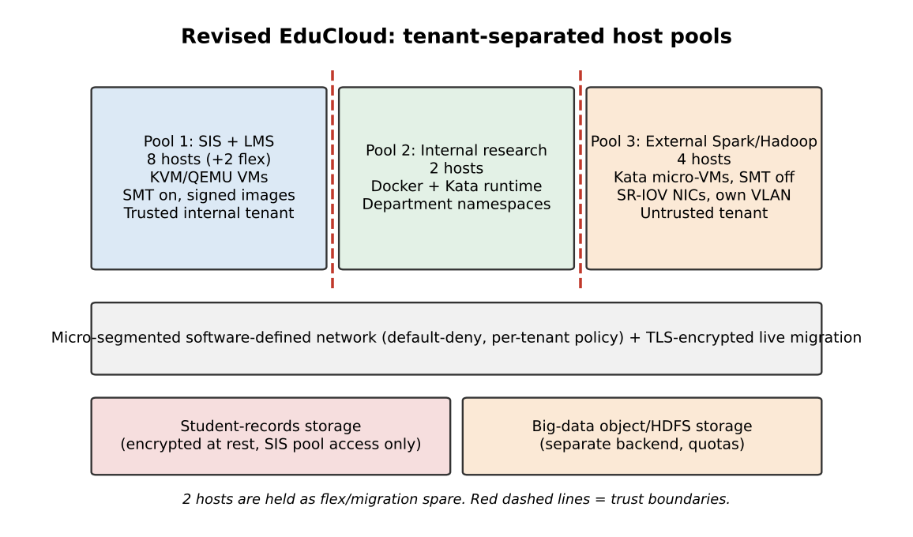
Figure 12.1: Revised EduCloud architecture with separated pools and trust boundaries
Pool | Hosts | Technology | Key controls
1: SIS + LMS | 8 (+2 flex) | KVM/QEMU VMs | Dedicated hosts, signed images, encrypted migration, encrypted storage, SMT left on (no untrusted co-tenant)
2: Internal research | 2 | Docker plus Kata | Namespaces and cgroup limits, seccomp, per-department network segments
3: External Spark/Hadoop | 4 | Kata micro-VMs | SMT off, SR-IOV NICs (η ≈ 0.98), separate VLAN and storage, I/O limits

Registration-week handling: the two flex hosts are borrowed from the internal-research pool during registration week (research VMs are paused or migrated), giving the SIS pool 10 hosts and the 62% peak utilisation computed above. Effect on density: the external pool runs fewer instances per host because SMT is off (usable cores fall about 25%) and Kata overhead is higher, but the memory limit remains the binding one (about 60 instances). Throughput: SR-IOV raises per-job network throughput from ηL/n with η = 0.85 to about 0.98 L/n, e.g. at n = 8, from 2.66 to 3.06 Gbps. Attack surface: external workloads never share a host, kernel, VLAN or storage backend with student records, so the regulation’s isolation requirement can be demonstrated by network policy, host-pool configuration and storage access lists.

D. Evidence-Based Defence
- Model evidence: the 8-host SIS pool is overloaded at peak (78%) but 10 hosts meet the 70% target (62%), which justifies borrowing flex hosts.
- Isolation evidence: Task 5 shows shared-kernel Docker is highest risk for untrusted tenants; Task 6 requires I ≥ 4 for both SIS and external pools, which KVM (4) and Kata (4.5) meet.
- Experimental evidence: use your noisy-neighbour result (Graph 2) to show how much a co-located batch job hurts a latency-sensitive victim, and your mitigation result (Table 9.3) to justify the SMT-off cost. [Insert your measured noisy-neighbour and mitigation numbers here]
- Cost/density trade-off: pool separation costs flexibility (statistical multiplexing is lost between pools) but is the only design that satisfies both the 10% degradation limit for SIS and the regulation. Total hosts remain 16, so no new capital cost is needed.
- Residual risks: hypervisor vulnerabilities, misconfigured segmentation and operator error. They are managed by patching through encrypted live migration and by regular audits of pool boundaries.

Supplementary analysis for Task 12
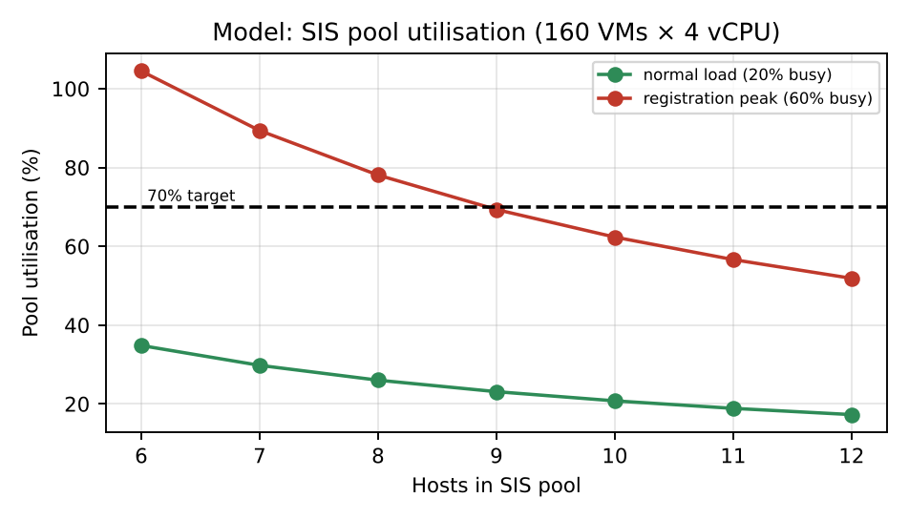
Figure 12.2: SIS pool utilisation against pool size at normal and peak load
Figure 12.2 shows that at normal load even a small pool is comfortable, but at the 3× registration peak a pool of 8 hosts is above the 70% target (78%) and 10 hosts is below it (62%). This is the quantitative reason for the two flex hosts.

12.1 Big-data workload sizing in the external pool
Consider a shuffle phase moving 2 TB between the 4 external hosts. With software networking (η = 0.85) the aggregate usable bandwidth is 4 × 0.85 × 25 Gbps = 85 Gbps, so the transfer needs 2 × 10^12 × 8 / (85 × 10^9) ≈ 188 s. With SR-IOV (η = 0.98) the bandwidth is 98 Gbps and the time falls to about 163 s, which is a 13% reduction. Since jobs run for hours, this saving applies to every shuffle stage and also frees CPU otherwise spent forwarding packets (the 2.5-core cost computed in Task 2 for a software path). Using both NICs per host (50 Gbps) halves the transfer time again but should keep management and storage traffic on separate VLANs.

12.2 Handling of the registration-week peak
Phase | Action
Two weeks before | Freeze live-migration patching; confirm images are signed and patched; load-test the SIS pool.
One week before | Move the two flex hosts into the SIS pool; pause or migrate internal research VMs; cap external I/O with quotas.
During | Monitor steal time, p95 latency, memory pressure and failed logins; autoscale web tiers inside the SIS pool.
After | Return flex hosts to research; resume migrations and patching; review metrics against the model.

12.3 Migration policy under the new regulation
- SIS pool: live migration only inside the pool, encrypted (TLS/IPsec), on a dedicated migration VLAN, and only outside the peak window.
- External pool: restart-based maintenance; jobs are rescheduled, so no memory images leave the host.
- Cross-pool migration is forbidden by policy and blocked by network rules, which makes isolation demonstrable in an audit.

12.4 Evidence for the regulator
The regulation requires demonstrable isolation of student records from external tenants. The evidence package is: (1) the host-pool inventory showing that no external VM is placed on a SIS host; (2) network policy exports showing default-deny between pools; (3) storage ACLs separating the student-records backend; (4) encryption configuration for storage and migration; (5) results of the security validation commands in Task 8.6 run on each pool; and (6) periodic scan reports confirming the rules still hold.

12.5 Residual risks after redesign
Risk | Level | Comment
Cross-pool misrouting by operator error | Medium | Automated verification tests run after every network change.
Hypervisor zero-day affecting both pools | Low–Medium | Two different isolation stacks reduce but do not remove common-mode failure; patch rapidly.
Reduced flexibility between pools | Low | Flex hosts and a documented borrowing procedure.
External tenant exhausting shared storage network | Medium | Separate storage backend and QoS limits.

12.6 Pool allocation in normal weeks and in registration week
Section C describes a 16-host split. To avoid confusion about the flex hosts: in normal weeks the two flex hosts run internal-research workloads, so research uses 4 hosts (2 + 2 flex), SIS uses 8 and the external pool uses 4. In registration week the two flex hosts join the SIS pool, giving SIS 10 hosts and research 2. The external pool is unchanged because its I/O is capped by quotas. The total never exceeds 16 hosts, so no capital purchase is needed.
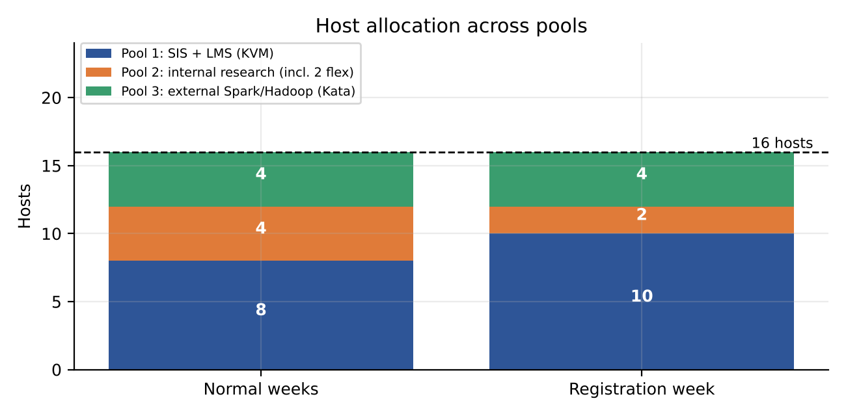
Figure 12.3: Host allocation across the three pools in normal weeks and in registration week

12.7 Network and storage segmentation
Figure 12.4 shows the separation that the regulator will want to see. Each pool has its own VLAN, the core firewall denies traffic between pools by default, and the student-records storage backend accepts connections from Pool 1 only. The external pool has a separate big-data storage system with I/O quality-of-service limits, so a long shuffle cannot starve the SIS of disk or network capacity.
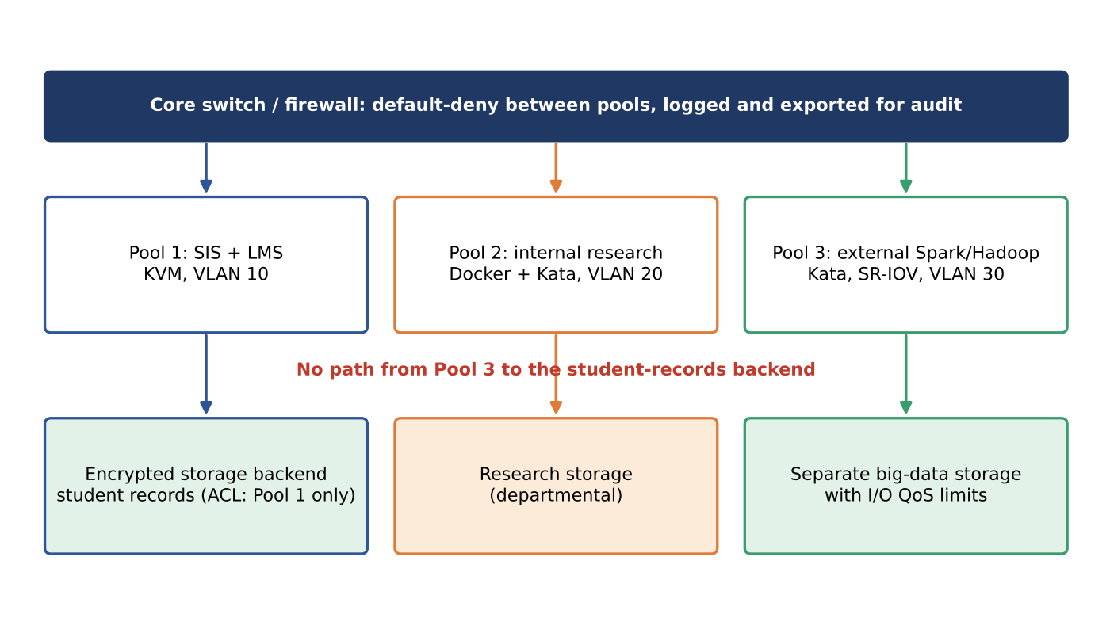
Figure 12.4: Network and storage segmentation of the revised EduCloud design

12.8 Shuffle time in the external pool
Section 12.1 computed that a 2 TB shuffle takes about 188 s over software networking and about 163 s with SR-IOV. Figure 12.5 shows the comparison. For a job with many shuffle stages the saving accumulates, and the CPU that would have forwarded packets in software is returned to the Spark executors.
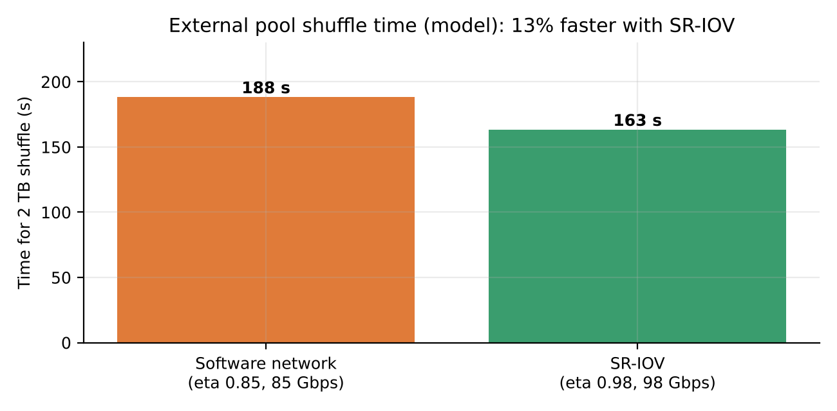
Figure 12.5: Modelled 2 TB shuffle time in the four-host external pool with and without SR-IOV

12.9 Retain, modify or redesign: options compared
Criterion | Retain original | Modify (chosen) | Full redesign (all Kata or dedicated clusters)
Meets 10% degradation target for SIS | No (batch jobs share hosts) | Yes (pool 1 at 62% peak utilisation) | Yes
Demonstrable isolation for regulator | No | Yes (host pools, VLANs, storage ACLs) | Yes
Hosts needed | 16 | 16 | More than 16 (loss of multiplexing across all tenants)
Change effort | None | Moderate: new pools, SR-IOV, policy | High: new runtime for every workload
Operational risk | High at registration | Medium (two stacks to operate) | Medium to high (new technology for SIS)
Fit for external Spark/Hadoop | Poor | Good (Kata, SR-IOV, separate storage) | Good
Table 12.1: Comparison of the three possible decisions.
The modify option is the only one that satisfies the performance target and the regulation without exceeding the existing 16 hosts, which is the logical basis of the defence in section D.

12.10 Acceptance tests for the redesigned platform
Test | How to run it | Pass criterion
Cross-pool reachability | From a Pool 3 instance, try to reach Pool 1 and the student-records storage | All attempts blocked and logged
Placement audit | Export the scheduler inventory | No external instance on a Pool 1 host
Registration-peak load test | Replay 3x the normal request rate against the SIS pool with the 2 flex hosts | Utilisation at or below 70%; p95 within target
Noisy-batch test | Start a shuffle in Pool 3 while loading the SIS pool | SIS p95 latency change within agreed limit
Migration encryption | Capture traffic on the migration VLAN during a test migration | No plain-text memory content visible
SMT state | cat /sys/devices/system/cpu/smt/active on Pool 3 hosts | Value 0 (off)
Image admission | Try to start an unsigned image in each pool | Start refused
Table 12.2: Acceptance tests that provide evidence for the regulator and for the defence.

Appendix A: Glossary
Term | Meaning
VM exit | A transition from guest mode to the hypervisor when the guest executes an instruction or event that must be handled by the host.
EPT | Extended page tables, hardware support for translating guest-physical to host-physical addresses.
Steal time | Time a runnable vCPU waits because the physical CPU is busy running something else.
Overcommit ratio R | Number of vCPUs allocated divided by physical cores available.
KSM | Kernel same-page merging; shares identical memory pages between VMs.
Ballooning | A driver in the guest that returns unused memory to the host.
Namespace / cgroup | Linux features that isolate what a process can see and limit what it can use.
seccomp | A filter that restricts which system calls a process may make.
SR-IOV | A NIC feature that presents virtual functions directly to guests, bypassing the software switch.
SMT | Simultaneous multithreading; two hardware threads share one core.
KPTI | Kernel page-table isolation, a mitigation separating user and kernel address spaces.
Micro-segmentation | Fine-grained, default-deny network policy between workloads.
TCB | Trusted computing base: components whose failure breaks the isolation guarantee.
Pre-copy migration | Live migration that repeatedly copies dirty memory pages until a short final stop-and-copy.

Appendix B: Anticipated Viva Questions
- Why can a VM guest’s system calls run at near-native speed while a privileged instruction costs a VM exit?
- Why is memory, not CPU, the binding limit for density in this model, and what would change that?
- What does the steal-time formula 1 − 1/R tell you about user-visible latency at R = 4?
- Why can a container escape be more damaging than a VM escape in this setting?
- Why is SMT-off unnecessary for the SIS pool in the final design but needed for the external pool?
- When does pre-copy live migration fail to converge, and what are the alternatives?
- Which model constants would you measure first to improve accuracy, and why?
- How does SR-IOV change the isolation and the performance of the external pool?
- What evidence would you show an auditor to prove external tenants cannot reach student records?
- How would the recommendation change if the isolation weight were reduced to 10%?

Appendix C: Sources to Consult
Use the official documentation of the technologies named in this report as primary references when completing your submission: the Linux KVM and QEMU documentation, libvirt documentation, Docker Engine documentation, the Linux kernel documentation on namespaces, cgroups v2 and the CPU vulnerability mitigations, the Kata Containers documentation, and the sysbench, fio, iperf3 and stress-ng manual pages. Add the exact titles and access dates you actually used in your reference list.

Appendix D: Checklist before submission
- Replace every yellow placeholder with your own details, measurements, graphs and screenshots.
- Re-run the model with your own test-bench parameters and update Tables 3.1–3.2 where you tuned the constants.
- Check that your written conclusions in Task 10 and Task 12-D match what your data actually showed.

Appendix E: Symbols and Model Equations
This appendix collects the notation and the main equations of Tasks 2 to 7 in one place, so that the derivations in the report can be checked quickly.
Symbol | Meaning | Value or unit
R | vCPU:pCPU overcommit ratio | 1, 2, 4, 8
s | Steal-time fraction, 1 - 1/R | 0 to 0.875
t_exit | Cost of one VM exit | 1.5 µs
f | VM exits per vCPU per second | 25,000 (KVM), 18,000 (Kata), 0 (Docker)
o_v | Fixed virtualization overhead, f x t_exit | 3.75%, 2.7%, 0%
gamma | Contention penalty per +1 of R | 0.008, 0.005, 0.006
C(R) | Effective capacity per busy vCPU | pCPU equivalents
m, m_o | Guest memory and per-instance overhead | 8 GB; 0.05 to 0.30 GB
sigma | Page-sharing (KSM) saving | 12% for KVM
N_max | Maximum instances before ballooning or swap | Instances per host
eta, eta_io | Network and storage path efficiency | 0.85 to 0.98; 0.75 to 0.95
L | Network line rate | 25 Gbps
R* | Maximum overcommit at the degradation limit | 8.8, 21.0, 13.2
I | Isolation score | 1 to 5
Z, lambda, w_k, c_h, H_k | Cost function, risk weight, tenant sensitivity, host cost, hosts in pool k | Task 6
Table E.1: Notation used in the report.
Quantity | Equation | Section
Exit rate | f = f_base + a x IOPS | 2.2
Packet rate | pps = line rate / (8 x frame size) | 2.2
CPU capacity | C(R) = (1/R) [1 - f t_exit - gamma (R - 1)] | 3.1
Memory limit | N_max = floor(M_use / (m + m_o)); with sharing, floor(M_use / (m (1 - sigma) + m_o)) | 3.2
Network share | T(n) = eta L / n | 3.3
Storage share | IOPS(n) = eta_io x IOPS_dev / n | 3.6
Density limit | R* = 1 + (0.10 - o_v) / gamma; CPU-limited instances = floor(64 R* / 4) | 3.4
Response time | W = S / (1 - rho) | 3.8
Migration time | T = V / (B - D) | 4.7
Cost function | Z = sum over k of [c_h H_k + lambda w_k (5 - I_k)] | 6
Prediction error | error % = 100 (measured - predicted) / predicted | 10
Table E.2: Summary of the main equations.

Appendix F: Additional Glossary Terms
Term | Meaning
virtio | A standard set of paravirtual device drivers that let a guest exchange I/O with the host through shared queues instead of emulated hardware.
vhost | A mechanism that moves virtio back-end processing into the host kernel (or a separate process) to reduce exits and copies.
IOMMU | Hardware that translates and restricts device memory access, so a passed-through device cannot read memory that belongs to another guest.
virtiofsd | The host-side daemon that serves the virtio-fs shared filesystem to a Kata micro-VM.
conntrack | The Linux netfilter table that tracks network connections; its size and lookup cost grow with the number of connections.
sVirt | A SELinux-based feature that labels each VM process so that a compromised QEMU cannot access other VMs.
Auto-converge / post-copy | Migration techniques that throttle the guest or start it on the destination before all memory has been copied, so that migration finishes even for busy VMs.
CRIU | Checkpoint/restore in user space, used experimentally to migrate containers.
M/M/1 queue | A single-server queue with random arrivals and service times, used for a first estimate of response time as utilisation grows.
MAPE | Mean absolute percentage error between predicted and measured values.
Service-level objective (SLO) | A measurable target for a service, such as a latency or degradation limit.
Table F.1: Additional terms used in this edition.

